- Introduction
Association of Russian Lawyers for Human Rights is an independent human rights organization, which conducts monitoring of the observance of human rights and freedoms in Russia and abroad for over ten years. Independent experts of the Association - lawyers, human rights defenders, civil activists, public figures – conduct the monitoring of the observance of human rights and freedoms.
Association of Russian Lawyers for Human Rights announced the campaign for protection of human rights of Ukrainian people in connection with the large amount of complaints about violation of human rights and freedoms, which was received by specialists of Association from Ukraine since February 2014.
The specialists of the Association of Russian Lawyers for Human Rights have prepared an interim report about the violation of human rights and freedoms in Ukraine, including the monitoring data of the Association from February to April 2014.
An interim report was published on the website www.rusadvocat.com, in the mass media and was sent to the state bodies of Ukraine.
The report contained the information about the situation with human rights in Ukraine: the current situation at the time of publication of the report, the qualitative changes of the observance of human rights and freedoms, the dynamics of changes of the situation with human rights and freedoms. The report included the recommendations of the specialists of Association of Russian Lawyers for Human Rights about the elimination of the violations of human rights and freedoms.
The specialists of Association of Russian Lawyers for Human Rights made the decision to prepare the special report in accordance with the principles of the UN Convention against Torture and Other Cruel, Inhuman or Degrading Treatment or Punishment and the Optional Protocol to the Convention adopted Resolution 57/199 UN General Assembly of 18 December 2002, as well as the provisions of the Geneva Convention of 12 August 1949 on the protection of Civilian Persons in Time of War, of the Additional Protocol to the Geneva Conventions of 12 August 1949 relating to the protection of Victims of International Armed Conflicts (Protocol II) on 8 June 1977.
The experts note, that during the preparation of the report they revealed the massive and systematic violation of Art. 5 of the Universal Declaration of Human Rights, which guaranteed that "no one shall be subjected to torture or to cruel, inhuman or degrading treatment or punishment", as well as the UN Convention against Torture and Other Inhuman or Degrading Treatment or Punishment and the Optional Protocol to the Convention, Resolution 57/199 adopted by the UN General Assembly on December 18, 2002.
Within the framework of the monitoring the specialists of Association of Russian Lawyers for Human Rights conducted the analysis of the observance by Ukranian bodies the Article 5 of the Universal Declaration of Human Rights, the UN Convention against Torture and Other Cruel, Inhuman or Degrading Treatment or Punishment, the Optional Protocol to the Convention, adopted by Resolution 57/199 of the UN General Assembly December 18, 2002. The mass media and NGOs repeatedly reported about the conducting of the monitoring.
The experts noted that the objective of the monitoring is the human rights and the protection of human rights. The report is not pursue the goal of the interference in internal affairs of Ukraine and not pursue any political goals. The aim of the report is the observance of human rights and freedoms.
The experts drew attention, that they received the complaints about the torture from any political forces, NGOs, civil activists, ordinary citizens independently of their political views, nationality, language, cultural and religious differences, sexual orientation and other differences.
The experts of Association of Russian Lawyers for Human Rights had analyzed the reliability and validity of the complaints and messages, all facts have got an objective assessment by independent experts. All confirmed facts were included in report dedicated the observance of Art. 5 of the Universal Declaration of Human Rights, the UN Convention against Torture and Other Cruel, Inhuman or Degrading Treatment or Punishment, the Optional Protocol to the Convention, adopted by Resolution 57/199 of the UN General Assembly on December 18, 2002.
The experts of Association of Russian Lawyers for Human Rights draw the attention that the report was prepared by independent experts, who do not pursue any political goals, who have no any personal sympathies or hostile relationship to persons or organizations mentioned in this report. The information is objectively and impartially.
The report is prepared in accordance with the guidelines regarding the format and content of the initial reports, which in accordance with the article 19 must be submitted by States parties to the Convention against Torture, adopted by the UN Committee against Torture (CAT / C / 4 / Rev.3) July 18 2005., and in accordance with the findings and recommendations and decisions of the UN Committee against Torture on complaints and reports under the UN Convention against Torture and Other Cruel, Inhuman or Degrading Treatment or Punishment and its Optional Protocol, adopted by Resolution 57/199 of the General Assembly UN December 18, 2002.

II. list of abbreviations
ATO: Antiterrorist Operation
CAT: Committee against Torture
ICCPR: International Covenant on Civil and Political Rights
NGO: Non-governmental organization
UN: United Nations
UNCAT: United Nations Convention against Torture and Other Cruel, Inhuman or Degrading Treatment or Punishment
UNIAN: Ukrainian independent news agency (News)
SESU: State Emergency Service of Ukraine
HHRG: Helsinki Human Rights Group
DF: Detention facility
RSA: Regional state administration
MIA: Ministry of Internal Affairs
SSU: Security Service of Ukraine
SMM: Special monitoring mission
III. Glossary of specialized terms
Statement (of torture) | Statement (which has not been proved or disproved) about the case of torture
Complaint | The message (or other form of information), which addresses to any international organization. The term is used in the United Nations for statements within the procedure of individual complaints. The person who wrote the complaint, usually called the author of the complaint.
Notification | The evidence, which confirms of disproves the validity of any statements
Introduction (of agreement) in force | The moment of the beginning of the discharge of agreement.
Non-judicial (for example, extrajudicial execution) | Not specified by the judge or is not a consequence of the judicial proceedings
Grave human rights violations | Particularly serious forms of human rights violations, such as torture, unlawful killing, etc.
Fulfillment (of obligations) | The method, which may be used for the fulfillment of obligations, or measures aimed at achieving of the fulfillment.
Impunity | The avoidance of the punishment for illegal or undesirable behavior.
Monitoring | The search and getting of information for the report about any situation or case
Ratification | The process that obliges the state to comply with the conditions of the agreement
Recommendation | The proposed course of action. The recommendation is not legally binding.
Compensation | The measures for the compensation of damage
Reservation | The state may register the reservation, which may somewhat change the conditions of the agreement
Resolution | The official decision of an international body, often using in the voting. The resolution is recommendatory character, non-legally binding.

IV. The accordance of the report to articles of the UN Convention against Torture and Other Cruel, Inhuman or Degrading Treatment or Punishment.
The experts of NGO "Association of Russian Lawyers for Human Rights" during the preparation of the report were guided by the fact that the activities of the Committee against Torture is carried in accordance with Article 20 of the Convention, and in particular:
1. In accordance with paragraph 1 of Article 20 of the CAT, if the Committee receives reliable information which appears to contain well-founded indications that torture is being systematically practiced in the territory of a State party, the Committee shall invite that State Party to cooperate in the examination of the information and to this end to submit observations with regard to the information concerned.
2. The authors of the report are knowledgeable that according to the Rule 75 of the Rules of procedure of the Committee the Secretary General shall bring to the attention of the Committee information that is presented or deemed submitted for consideration by the Committee in accordance with paragraph 1 of Article 20 of the Convention.
3. The authors of the report is taken into account the condition, that the Committee takes no information if it concerns a State Party which is in accordance with paragraph 1 of Article 28 of the Convention upon ratification or accession thereto declare that it does not recognize the competence of the Committee provided for in Article 20 unless that State party has subsequently withdrawn its reservation in accordance with paragraph 2 of Article 28 of the Convention.
4. The authors of the report are knowledgeable that in accordance with the provisions of Article 20 and Rules 78 and 79 of the Rules of procedure, all documents and materials of the Committee relating to its functions under article 20 of the Convention are confidential and all the meetings concerning its proceedings under that article are closed. However, in accordance with paragraph 5 of Article 20 of the CAT, after consultation with the State Party concerned, the Committee may decide to include a summary account of the results of the proceedings in its annual report, which is submitted to the States parties and to the General Assembly.
According to Art. 20 of the CAT the report contains the information and statements concerning the widespread practice of using of torture and the total impunity for acts of torture and the absence of the criminal responsibility in domestic legislation.
The presentment of the facts, cases, the messages, all forms of information, which contained in the report complies the requirements of Art. 22 of the CAT.
In accordance with paragraph 1 of article. 22 the report contains the information (messages) about torture and about the victims of the torture in Ukraine. According to paragraph 2 of article 22 the report is not anonymous, this report does not contains the abuse of the right for submission the information about the torture.
In accordance with paragraph 3 of Article 22 the autors of the report take into account the fact that any information submitted to the Committee in accordance with Article 22 of the Convention, the Committee shall bring to the attention of the State Party to this Convention, moreover, experts welcome the Committee's powers, allowing consider written explanations or statements clarifying the matter and any measures that could be taken by that State. The authors of the report provided information and messages so that the Committee may realize paragraph 4 Art. 22 of the CAT.
This report meets the requirements of Article 22 of the Convention to paragraph 5, and information has not been and is not being examined under another procedure of international investigation or settlement, and the domestic remedies are ineffective in respect of persons who are victims of violations of the CAT.

V. The criteria of the selection of the information
The experts of the Association of Russian Lawyers for Human Rights have used the methodology, which appropriated to the international context, which does not depend on the procedural norms of one or the other legal system, particular legal system. The approach to the analysis of the information meets the standards of the analysis which were elaborated in guidance of the Ombudsperson "Approach to, and Standard for, Analysis, Observations, Principal Arguments and Recommendation" (http://www.un.org/en/sc/ombudsperson/ approach.shtml)
The specialists were guided by certain criteria and standards, when they analyzed the complaints, messages and all forms of information from Ukraine about the torture or other cruel, inhuman or degrading treatment or punishment in the period from November 2013 to October 2014.
Each unit of information had assessed from the perspective of relevance, concreteness and reliability. The experts had checked the reliability/validity of the information from the point of view of the granularity, specificity, particular characteristics, sources, validate of the information in mass media, different resources. The specialists investigated the totality of the circumstances and all the conclusions which have arose from the collected and summarized information in each case.
During the preparation of the report the specialists guided by such international instruments as the Convention against Torture and Other Cruel, Inhuman or Degrading Treatment or Punishment (December 10, 1984.); International Covenant on Civil and Political Rights (16 December 1966); Declaration on the Protection of All Persons from Torture and Other Cruel, Inhuman or Degrading Treatment or Punishment (the forerunner of the Convention against Torture), and so on.
The authors of the report used the conventional criteria and definitions and interpreted them as follows.
The reliability is the confirmation of the information from trusted sources, the compatibility with other information, the confidence of the source and the motivation, the authority of the source, the properties of the information channel, the accordance of the information and the description to reality.
Topicality is the degree of the accordance of the information to the current time.
The specialists specified the detailed information in each case:
- The full name of the victim (s), if it is available;
2. Date (at least the month and year), when the torture was used;
3. The place where the person was detained (city, province, etc.), and the place the torture was used (if known);
4. The description of the executors of the violation (positions of authority/belonging to the State);
5. The description of the form of the torture, which was used, the form of the mutilations or the statement about the reasons, which let to suggest the presence of the of the torture against a person;
6. The identity of the person or organization submitting the complaint (message) (name / title and address, which will be kept confidential).
The experts distinguish the complaints (messages) containing the information about the violations by person or groups (not government officials), and presented the information in the report, which may indicate that the government has been unable to implement the actions for prevention, investigation, punishment and the providing of compensation to the victim of the violations. The specialists had reflected the answers to the questions:
a) is there the a law providing responsible for the violation;
b) the refusal or failure of the authorities to register or investigate the case and other similar cases;
c) the failure of the authorities to bring the perpetrators to justice in this case and in other similar cases;
d) statistics and other data concerning the prevalence of the type of violation which the complaint (message) contains.
VI. Background information
Part I. General information, historical background
The process of formation of the Ukrainian state began during the First World War. In 1917 the Central Rada of Ukraine issued a Third Universal, which proclaimed the establishment of the Ukrainian People's Republic. The ideologues of the establishment of the Ukrainian state were Hrushevsky, Simon Petlyura, Vladimir Vinichenko, Hetman Skoropadsky and others; also the philosophical concept of Michael Dragomanov had been used. The social democratic political platform had dominated in the construction of an independent Ukrainian state in Ukrainian ideological concept. However, a weak government led to the collapse of the Ukrainian People's Republic; then the Bolsheviks had formed the Ukrainian Soviet Socialist Republic in most parts of Ukraine in 1922. The different parts of the territory of Ukraine came under the jurisdiction of Poland, Czechoslovakia and Romania.
In 1929 on the territory of Ukraine, which was controlled by Poland was created the Organization of Ukrainian Nationalists (OUN). The organization combined the radicals, who were dissatisfied of the moderate policies of other political forces, which did not seek to establish an independent Ukrainian state. Radicals accused the socialist and liberal forces in the defeat of the Ukrainian People's Republic in 1917-1920. The influence of nationalist ideology had increased in Europe and became the base of the OUN. OUN has highlighted the importance of a strong elite and national solidarity: so was created an ideology natsiokratiya, one of the branches of Nazism. OUN used the revolutionary and terrorist methods of struggle to achieve the objectives. The OUN ideologists were Eugene Konovalets, Stepan Bandera, Andriy Melnyk. OUN has carried out the series of the terrorist attacks and assassinations against the Polish population, politicians, intellectuals, and politicians in other countries. After the murder of one of the ideologists of the OUN - Eugene Konovalets - OUN was split into two organizations: the OUN-M, the so-called Melnykovtcy, who supported the idea of the collaboration with Hitler without establishment of an independent Ukrainian state, and the OUN-B, the so-called Banderovtcy, who supported the idea of cooperation with Hitler for the using the forces of Nazi Germany for the establishment of an independent Ukraine. However, despite the antagonism between these organizations they were united by ideology - natsiokratiya and support of Nazi Germany against the Soviet Union, both organizations participated in the beginning of the invasion of the Soviet Union were on the side of Nazi Germany. However, during the Second World War, OUN-B tried to establish an independent Ukrainian state and the ideologists and their associates of the establishment of an independent state were suffered by the mass arrests, for example, the ideologist Stepan Bandera was placed to the concentration camp Sachsenhausen. OUN-M dissociated itself from the support of Bandera and his organization and continued to fight on the side of Hitler and, in particular, participated in the ethnic cleansing of Jews, Russian, Ukrainians, etc. Detachments of the OUN-M is in fact a unified organization with the Don Cossacks led by General Pyotr Krasnov and Kuban Cossacks led by Andrew Shkurko (in fact, we are talking about military units of Nazi Germany). The remainder of the OUN-B went underground and started fight against Hitler. Upon the occurrence of the USSR the OUN-B actually teamed again with the OUN-M and received support from Nazi Germany to conduct sabotage and counter-insurgency operations on the territories liberated by Soviet Union - in the Western Ukraine and in Galicia. These military units were called Ukrainian Insurgent Army (UIA).

After the liquidation of the UIA and one of the leaders - Roman Shukhevych, OUN-M and OUN-B began to exist autonomously, but, after the death of Stepan Bandera the OUN-B ceased to exist, but OUN-M - continued their activities. Later, at the end of the 1980s, supporters of the OUN-M became the basis for the formation of the nationalist parties and organizations in Ukraine, which got a new life during the revival of the independent Ukrainian state. National heroes of the Ukrainian state in accordance with the ideology of OUN-M steel are Eugene Konovalets, Andrew Melnik, Stepan Bandera, Roman Shukhevych and others, who supported the side of Nazi Germany during the Second World War. The ideology of the created on the basis of the OUN-M organizations was and is natsiokratiya; while these forces condemned and continue to condemn the socialist ideas, the ideas of liberalism, the idea of internationalism, human rights and freedoms, political pluralism and democracy, the supporters of these ideas were harassed by natsiokratov officially. Nazi forces are represented in the Ukraine in many structures and authorities at all levels since 1991.
With the government support the natsiokraty actively pursued a policy on debunking exploits fighters against fascism during the Second World War, promoting a glorification of Nazi Germany since 1991. The Ukrainian mass media willingly disseminate the information, which misrepresent the facts and the information about the Second World War, the fact, which related with the Soviet soldiers, fighters against fascism. The Ukranian mass media sounded the calumny slander against the Soviet soldiers, discredited the image of the warrior-liberator. But the crimes of the Nazis were suppressed, for example, the massacre at Babi Yar, the mass extermination of Jews in Ukraine and active participation in this division of the OUN-M; the history books are justify the fascism. The nationalist organizations involved the young people in their activities, they controlled the youth policy, oriented the youth to Nazism, as the result of which was the rise of neo-Nazi sentiment among Ukrainian youth and replenishment at the expense series of neo-Nazi groups, including the involvement of minors. The result of the neo-Nazi organizations in Ukraine was the appearance of a plurality of youth groups with the neo-Nazi views, these groups were used by various nationalist forces to achieve the political goals. The neo-Nazi organizations actively promoted the idea of ethnic and genetic superiority of Ukrainians over oriental peoples.
Many information resources, the sites of the nationalist organizations, the scientific and educational literature promoted the idea of the genetic retardation Eastern peoples and especially Asian peoples, also promoted the idea of hatred due to genetic differences in relation to the Russian-speaking population, which neo-Nazis called the non-Slavic peoples, and the Finno-Ugric, and therefore they must be destroyed along with the other supposedly genetically backward peoples. The offensive terms concerning Russian-speaking population and the population of Russia are "katsap", "Moskal," etc. became common, and their using is not condemned at the official level. Native Russian speakers were not able to achieve the right to use their language officially by reason of the influence of neo-Nazi and other right-wing forces in the state policy. Under pressure of Nazi in Ukraine intensified the anti-Semitic sentiments and rhetoric, intolerance which based on a any difference, which went beyond the neo-Nazi ideology. As a result, the chauvinism, xenophobic rhetoric at the official level, discrimination based on ethnicity, religion, sexual orientation, gender differences became conventional.
The growth of the neo-Nazi sentiments reached its peak after the start of the political crisis caused by the situation in Ukraine - failure to sign an Association Agreement with the European Union, divided society into EU-integrators and EU-sceptics.
The supporters of European integration were split on the party, one of them supported the peaceful protests, other – the radicals, which were represented by neo-Nazi forces and politicians, who decided to use the force to overthrow the government, which not signed an association agreement with the European Union.
The split led to the unification of various neo-Nazi forces in a single political force called "Right Sector", which began to actively lead the protest movement in the direction to the force scenario.
Neo-Nazi association "Right Sector" had a resistance force in response to demands from authorities to stop the protest, but the protests escalated into riots and clashes, which in turn evolved into armed clashes between protesters and government representatives. Despite the political agreement reached between the various social forces to dismiss the government and presidential elections, the collision did not stop, but intensified. As a result, February 22, 2014 in Kiev, protesters, including the key role played by neo-Nazi forces, seized the power.
In the subsequent the neo-Nazi forces began to fight with the dissidents - especially with opponents of neo-Nazism and fascism, with the socialists, liberals, communists, democrats; began to carry out raids and punitive operations, observed seizures and seizure of property, violence and intimidation of supporters of Ukraine's integration with Russia or Russian language official recognition in Ukraine.
As a result of intimidation and terror of the Ukrainian population (despite the active participation of neo-Nazis in the overthrow of the government) the neo-Nazi sentiment in the Ukraine caused fear in society, which led to the separatist sentiment in the east of Ukraine among the Russian-speaking population. The result of this was the release of the Crimea from Ukraine in March 2014. At the same time the political crisis erupted in eastern Ukraine, where the Russian-speaking population has been subjected to intimidation and harassment by the "Right Sector", which began to implement targeted retaliatory operations in respect of its most active opponents. Wave of repression against Rusyns swept across Western Ukraine. The policy of neo-Nazis has replaced the official policy and it led to greater political crisis and the split of Ukraine in the Russian-speaking part (east) and Ukrainian (center-west), which became the beginning of military confrontation and self-proclamation of independence of the republics of New Russia - People's Republic of Donetsk, Luhansk People's Republic.
Kiev authorities conducted the punitive operations and in some regions the authorities crushed the separatist sentiments, but in Lugansk and Donetsk confrontation developed into a large-scale military conflict with the use of the regular army, artillery, aircraft, etc.
Experts note that the conflict has all the hallmarks of an armed conflict not of an international character. However, despite the hostilities, the Kiev authorities refused to recognize it, declaring military confrontation anti-terrorist operation (ATO) to have a reason to refer to the fact that the rules of international humanitarian law, including the regulatory mechanism of the protection of civilians, as well as other guarantees international law to conflicts of this nature do not apply to the conflict in eastern Ukraine.
Experts note that the Ukrainian authorities have thus had created the conditions for violations of international humanitarian law, contributed to the massive violation of human rights and freedoms and crimes against humanity - torture, murder, etc. According to experts, the conflict erupted in November 2013 to October 2014 and it led to numerous complaints about torture, murder, use of prohibited weapons, war crimes, crimes against humanity (ethnic cleansing), and as a result - a huge number of refugees.
Thus these crimes are required the comprehensive full independent international investigation. After Minsk Agreement the civilians from the east of Ukraine began reporting about the mass graves and torture of civilians, dissidents, people who are persecuted for political and other differences.
The experts note that the escalation of the conflict in Ukraine, numerous civilian casualties, dissidents, people who are persecuted on any differences, torture, inhuman treatment are the result of the failure to build a dialogue in Ukrainian society between the different political forces, and the result of amplification of neo-Nazi forces and moods in Ukraine led to its actual split on ethnic, cultural, linguistic and religious grounds.
The experts also have noted that in the evaluation of events in Ukraine is necessary to take into account the fact that during the assessment of the crimes of Nazi Germany at the Nuremberg trials on various political and historical reasons not fully assessed the activities of the Nazis in Ukraine - the OUN-B, OUN -M, UIA; was not carried out an investigation into the crimes of these organizations; the perpetrators have not been punished, and have not been convicted of crime that led to Hitler's followers in Ukraine in modern history in the form of neo-Nazis. The experts note that the revival of Nazism in Ukraine and the committed crimes should get the assessment, the investigation, and if confirmed - to follow the conviction and sentence. The information and the result should be brought to the Ukrainian society and the world, to the future generations, that Nazism in any forms - crime and criminals must and will be punished.

Part II. International law and legislation of Ukraine. The practice of applying
In 1973 Ukraine ratified the Universal Declaration of Human Rights and thereby recognized the scope of Article 5, which guarantees that "no one shall be subjected to torture or to cruel, inhuman or degrading treatment or punishment."
In 1987 Ukraine ratified the UN Convention against Torture and Other Cruel, Inhuman or Degrading Treatment or Punishment; the statement about the individual complaints were made by Ukraine in 2003.
The Optional Protocol to the Convention against Torture and Other Cruel, Inhuman or Degrading Treatment or Punishment was ratified by Ukraine in 2006.
Ukraine ratified the UN Convention against Torture and Other Cruel, Inhuman or Degrading Treatment or Punishment (1984) in accordance with its provisions, which develop and clarify the international standards in this area. According to the document Ukraine acknowledged that torture -is any act by which severe pain or suffering, whether physical or mental, is intentionally inflicted by or at the instigation of a public official on a person for such purposes as obtaining from him or a third person information or confession, punishing him for an act he has committed or is suspected of having committed, or intimidating him or other persons. Also the torture are considered actions that are intended to intimidate or coerce human or a third person to do anything, or to perform for any reason based on discrimination of any kind, when such pain or suffering is inflicted by a public official or other persons who act as official or at the instigation of or with the consent or acquiescence. At the same time, it is necessary to note that the International Convention on the Protection of All Persons from Enforced Disappearance, 2006 has not been ratified by Ukraine. The Convention declares that no exceptional circumstances whatsoever, they were not a state of war or threat of war, internal political instability or any other public emergency, may be invoked as a justification for enforced disappearance, and the enforced disappearance is considered to be the arrest, detention, abduction or deprivation of liberty any other form of representatives of the State or by persons or groups of persons acting with the authorization, support or acquiescence of the State, followed by a refusal to acknowledge the deprivation of liberty or by concealment of the fate or whereabouts of the disappeared person, which place such a person outside the protection of the law.
The UN General Assembly in 1979 adopted Resolution 34/169 and the Code of Conduct for Law Enforcement Officials. Article 5 of the Code provides that no officer of law enforcement can not inflict, instigate or tolerate any act of torture or other cruel, inhuman or degrading treatment or punishment, and no officer of law enforcement is not may invoke superior orders or exceptional circumstances such as a state of war or a threat of war, a threat to national security, internal political instability or any other public emergency as a justification of torture or other cruel, inhuman or degrading treatment or punishment. The prohibition derives from the UN General Assembly Declaration on the Protection of All Persons from Torture and Other Cruel, Inhuman or Degrading Treatment or Punishment. This interpretation does not include pain or suffering arising only from, inherent in or incidental to, lawful sanctions to the extent consistent with the Standard Minimum Rules for the Treatment of Prisoners.
The Article 28 of the Constitution of Ukraine guarantees that "everyone has the right to respect for his dignity. No one shall be subjected to torture or to cruel, inhuman or degrading treatment or punishment. No man without his voluntary consent cannot be subjected to medical, scientific or other experiments". These provisions of the Constitution of Ukraine meet the Article 5 of the Universal Declaration of Human Rights of 1948.
The Criminal Code of Ukraine provides the liability for torture, in particular, according to the article 127 of the Criminal Code "Torture - is the intentional infliction of severe physical pain or physical or mental suffering by beatings, torture or other acts of violence to coerce the victim or another person to commit acts contrary to their will, including obtaining from him or another person information or a confession, or to punish him or any other person for acts committed by him or any other person or of which he or another person is suspected, as well as for the purpose of intimidation or discrimination against him or other persons". The article establishes the responsibility for such an act is the imprisonment for the term of 2 to 5 years. The same actions committed repeatedly or by prior agreement by a group of persons, or motivated by racial, ethnic or religious intolerance, shall be punished by imprisonment for a term of 5 to 10 years.
With reference to statistics, jurisprudence, responsibility for torture in Ukraine from 2006, when the keeping of the state register of court decisions (EGRSR) was started to 2012 the first instance judges were issued about 15 judgments under Article 127 of the Criminal Code of Ukraine. Four judgments were imposed against the officials of the Ministry of Internal Affairs during seven years. An objective explanation of the difference between the number of complaints about the torture and the number of pending court cases and convictions is the application of Art. 365 of the Criminal Code "Abuse of power or official authority."
The persons against whom has been applied Art. 127 of the Criminal Code of Ukraine, may be divided into employees of MIA of Ukraine, ordinary citizens, engaged the torture against other persons, the citizens engaged in torture of minors hired workers of against the family members.
(http://argumentua.com/stati/osobennosti-pytok-v-ukraine-sudebnye-istorii )
The situation has not changed in 2008, when according to official statements of human rights organizations, in particular, the Ukrainian Helsinki Group said, that every 14th Ukrainian experienced the torture by the police, and at least 30% of criminal suspects face torture, by which the police knock the evidence from them. The human rights defenders said, that the police use the torture for the increasing the indicators of the crime detection. According to the information of the representatives of Ukrainian NGOs, the torture has led to the fact that in Ukraine the crime detection is 69%, when in Europe - is 40%, while in the US - 30%. The largest number of the torture by police, the human rights defenders said, occurs at the near railway stations or on the roads by road patrol service of police. However, the Ukrainian Parliament Commissioner for Human Rights has stated that the courts do not have the courage to make tough decisions with respect to the guilty in this shameful phenomenon as torture. (http://txt.rus.newsru.ua/ukraine/18aug2008/tortury.html)
In 2011 the Ukrainian human rights defenders stated, that every 40 minutes one human in Ukraine is exposed to torture: their statements were based on information from complaints and appeals to them. According to the NGOs information, with the help of cruel bullying police may knock the recognition of any crime. The human rights defender Yevhen Zakharov said: " The problem in scale larger than the tuberculosis epidemic - said the expert. - More than half a million suffer by tuberculosis, and over the past year 800 thousand humans were subjected to torture." The investigation of torture cases are extremely rare and not under Art. 127 of the Criminal Code of Ukraine ("Prohibition of Torture"), the human rights defender said.
"They are used mainly in Art. 365, 364 (" Malpractice "or" abuse of power "), - said the expert of Ukrainian Helsinki Group Lyudmila Klochko.
(http://www.segodnya.ua/ukraine/pravozashchitniki-zajavili-chto-pytki-v-ukraine-%E2%80%93-obydennoe-javlenie.html )
In 2011 the situation with the torture and the participation of the investigators, the question of compliance with the rule of law and discipline among investigators and the goal - to deal with the systemic irregularities in the conduct of investigative actions by investigators in prison - has become a priority for the new Minister of Internal Affairs of Ukraine Vitaly Zakharchenko. As follows from the Ukrainian media, torture and murder in detention centers of Ukraine became the common practice, however, despite the obvious deterioration Parliament Commissioner for Human Rights in 2011 officially declared that "every second policeman who committed torture gets real punishment".
(http://argumentua.com/novosti/za-pytki-i-ubiistva-v-sizo-glava-mvd-predlozhil-nakazyvat-distsiplinarno )
The reaction of the society in 2013 to the acquittal of innocent Alexander Bondarenko illustrates the situation with the torture in Ukraine over the past few years: in the district court of the city of Sumy (Eastern Ukraine) for the first time in the history of the Ukraine the courts jury acquitted the human: two librarians and kindergarten together with the two judges decided that the 20-year-old Alexander Bondarenko did not kill two women. Despite the using against Alexander Bondarenko the torture and fabrication of evidence by local investigators, he could prove his innocence. The opinion of the media that the judgment of acquittal, despite the fabrication of criminal prosecution and torture, an uniqueness of the case demonstrates the dynamics of deterioration of the situation with human rights and freedoms in Ukraine, the frequency of torture.
(http://censor.net.ua/news/257973/ukrainskiyi_sud_prisyajnyh_vpervye_vynes_opravdatelnyyi_prigovor_parnya_jestoko_pytali_v_militsii
According to the statistics of Ukrainian human rights defenders at 10 December 2012 more than 1,545 people were detained in Ukrainian detention facility more than 18 months without judgment of guilt; at 1 January 2013 - 1239 people.
According to the information of the Ukrainian NGOs specialists, from among 1545 people 541 (35%) are in detention facility since 2010, 509 people (32.9%) are in detention facility since 2011, 236 people (15.3 %) - since 2009, 71 people - since 2008. More than five years since 2007 in detention facility without judgment of guilt contained 38 people, another 18 - since 2006. The human rights defenders paid particular attention to the unique case: the human has been detained 29 December 2003 in Kherson more than nine years ago. The statistics shows, that people whose guilt has not been proven, continued to be detained despite the expiry of the maximum period of detention. Moreover, the Ukrainian courts at 2012 imposed less than 0.17% of judgment of acquittal - the lowest percentage last 7 years. (http://gazeta.zn.ua/internal/ukraina-strana-oficialno-razreshennyh-pytok-_.html )
The dynamics of deterioration in the human rights situation in Ukraine shows the discussion at the official level the permission of using of torture to certain groups of detainees. Thus, the Ukrainian official of MIA, the adviser Anton Gerashchenko suggested to use torture to people identified as terrorists. (http://joinfo.ua/politic/949214_Verhovnaya-Rada-Ukraini-razreshit-pitat.html )
It should be noted, that the adviser did not take into account that the time of the establishment of the membership of a person in the terrorist group is not more than two days. Moreover, the Adviser has ignored the action of the UN Convention against Torture, which was ratified by Ukraine. According to the information of the Ukrainian human rights defenders, such an initiative, which implies the haste in getting information by Prohibited Methods, officially calling the methods of getting evidence is the torture will be applied to the residents of Eastern Ukraine and will let to avoid responsibility of the executor.
The information of the human rights defenders confirmed by international human rights organizations. According to the Amnesty International (AI), Ukraine in recent years has become the greatest violator among post-Soviet states in the field of torture and abuse in the context of the ordinary criminal justice system. According to the report of the international organization, the serial abuse of Ukrainian law enforcement had documented for many years: every year in Ukraine there were several hundreds of thousands of cases of torture and other abuses. Thus, according to AI, three decades after the adoption of the UN Convention against torture, many governments are tortured disingenuous - they have the law, which ban the torture, but allows to use the torture in practice and allows to avoid responsibility of the executor. . (http://rusvesna.su/news/1399964101)
It should be noted that research of Amnesty International in recent years have demonstrated a large number of torture victims in Ukraine, and the reluctance of the authorities to fully implement systemic changes in legislation to eliminate them. According to the international human rights defenders, the definition of torture in the Criminal Code of Ukraine does not quite match those shown in the Convention, and the need to conduct independent and effective investigations into allegations of torture specified in the Convention, so far ignored by the Ukrainian authorities.
"For many years, these cruel and degrading crimes were committed outside the public attention - victims tortured behind closed doors, police stations or even outside, for example, in the forest, and then the evidence and complaints from victims may be destroyed and rejected by the prosecutors. But the cases of last year - from atrocities in Vradievka to abuse during Euromaidan - show to everyone the degree of irresponsible attitude of the authorities to their international obligations, "indicates an Amnesty International representative in Ukraine in its report in 2014. (http://www.unn.com.ua/ru/news/1341431-uryadi-u-vsomu-sviti-ne-vikonuyut-svoyikh-zobovyazan-schodo-vikorinennya-tortur-amnesty-international)
The experts note that the difficult situation with the torture in Ukraine worsened in 2014.
The widespread have got the use of torture right up the abduction of a person and beating in the streets of Kiev, capital of Ukraine and the degree of the degradation of the relations in society demonstrates the situation with the reporter of the newspaper "Navigator" Sergei Rulev, who suffered from the beatings, torture, humiliation in March 2014. It was the reaction for his independent position in covering the events in Ukraine autumn 2013 - winter 2014, in particular, he suffered for the interview with fighters "Berkut". According to the journalist, he was "caught, squashed and pulled into a tent in front of the House of Trade Unions. There I was insulted, kicked, "" They beat me 4 people, with them was a woman in a headscarf, which is not saying a word, kicked me in the groin. Then I was dragged to the building of Ministry of captured APC, where I was ransacked, they seized my documents, press card, accreditation of the Parliament (Verkhovna Rada), business cards, two phones and two cameras "- continued the reporter. <...> When I was back on the Khreschatyk, I began to scream and call for help, fell to the ground, they kicked me again, but no one responded <...> In the lobby they immediately started to beat me. In the courtyard the unknown people in camouflage clasped my hands, stripped me to the underwear and continued to beat me. They shouted, "caught!", " Berkut "kills us!". After that, the four of us piled on top of me on the floor, something pricked my hand - they say, "Now you're the bitch, will talk, what special services do you work!" - Says the reporter. According to the Rulev, when he was tied up, an unknown woman began to torture him with pliers - to pull the nails. " (http://rian.com.ua/politics/20140305/340522337.html )
The indicative the murder of Sergei Dolgov, Chief Editor of the newspaper "I want in the USSR", who had been abducted by the soldiers of the Ukrainian battalion "Dnepr-1". The journalist's body was found near Dnepropetrovsk, obviously, that he was suffered by torture. According to the information of Dolgov's friends, he was principled journalist, who held a position contrary to the views of the new Kiev authorities. Since the beginning of the armed conflict in the Donbass Dolgov collaborated with the project "White Book". He gathered the information about of violation of human rights by the security forces during the Ukrainian conflict. (http://www.topnews.ru/news_id_69568.html )
According to the research of Amnesty International, during the period from April to June 2014 in the Ukraine in the area of ATO in different regions of the country was stolen about five hundred people, at the same time, the experts paid the attention, the vast majority of the abducted were subjected to violence, torture, bullied and could serve as a "human shield" during the fighting in the Donetsk and Lugansk regions.
It is important to note that the monitoring mission of the UN Human Rights at the same period announced the other members of the abduction - 222 cases. The report of Amnesty International, which was presented in July 2014, states that "the abduction occurred throughout eastern Ukraine, including in the Donetsk and Lugansk regions. Among those who became the target of kidnappings, were not only the police, military and local officials, but also journalists, politicians, activists, members of election commissions and entrepreneurs».(http://www.golos-ameriki.ru/content/amnisty-international/1955765.html )

Experts note that it is appropriate to speak of a sharp deterioration in the human rights situation, increasing the number of cases of torture in Ukraine, starting from February 22, 2014, and provides the detailed statistics of cases of torture and murder during the events of February 22, 2014 and until the completion of this report, which are reflected in the special parts of the report.
VII. Torture and other cruel, inhuman or degrading treatment or punishment
The experts note that in Ukraine the torture, inhuman treatment are widespread and systematic. In its conclusions the experts guided by the explanations of the UN Committee against Torture.
Thus, according to the explanations of the CAT the systematic practice of torture is in the case when the torture cases are documented and are not unique and specific to a particular place or time, and are characterized by habitual, widespread and deliberate at the significant area of the country. On the other hand the torture may have the systematic character, but have not the direct intention of the government. It may be the consequence of the factors which the Government not control, and the practice of the torture may indicate a discrepancy between policy as determined by the government of the country, and its implementation by the local administration.

The systematic character of the practice of the torture may be explained by the gaps in the legislation, which provides opportunities to use the torture. In the analysis of information on torture and other cruel, inhuman or degrading treatment or punishment the experts guided by the principle that each unit of information is evaluated in terms of its relevance; take into account the specificity and accuracy of the degree of detail, its characteristics and source (if known), or additional supporting data and the availability of similar information from other sources. The specialists point out that they reflects the developments in Ukraine in November 2013, describe the situations, the documentary facts, the messages, all the information is presented in the chronological order, accompanying by detailed description, reference, also the specialists consider, that 22 February 2014 is the date, when the conflict started to escalate and the end of the reflected facts is 1 October 2014.
During the analysis of the information the specialists took into account the character of the conflict in Ukraine, the dynamics of the developments, including the participation of the governmental and non-governmental forces in the conflict, taking into account the fact that the both forces used the torture, being the political forces which pretended to the power, and occasionally, the forces were the subject of the power on the controlled territory, such as formed on the Maidan the organization "Right sector" with support of the nationalist ideology.
It is important to note that in the establishment of such movement involved the political parties and the leaders represented in the Parliament of Ukraine, and in the executive branch, and then the movement was used for political goals and the seizure of power in Ukraine, using movement as a force for the pressure on the people who were disagreed with the Nazi ideology, and used the movement as a structure, acting them as the law enforcement bodies of Ukraine. It is important to note that the movement guided by the law of the revolutionary time, which frequently extend beyond of the current legislation of Ukraine, as the non-governmental forces have repeatedly stated, for example 19 March 2014 the group of ultra-right members of the so-called People's Tribunal in Vinnitsa rudely demanded that the chief of the regional children's hospital Tatiana Antonets in connection with her political views (member of the Ukrainian Party of Region) considered her guilty in the "crimes of the previous government." Radicals said that in case of disobedience she will be punished "under the laws of harsh revolutionary time."
http://www.youtube.com/watch?feature=player_embedded&v=IAcIFK74zYc
Thus, the participants of the nationalist organization «Right sector» acted with impunity and implemented the political will of some political forces, «Right sector» increased its influence and increased the functional that led to the establishment of the so-called National Guard of Ukraine - the power structure, which combined the functions of the current regular army and law enforcement bodies, they acted on behalf of the government forces, acted under the laws of the revolutionary time.
In this connection, the experts consider, it is possible to speak talk about the existence of two subjects of the responsibility: on the one hand - the so-called government forces and on the other hand - non-governmental forces. The duplication of the state institutions has led to the situation when two subjects of responsibility formed and both acted as the authorities.
For example, November 2013 may be identified as the period of formation of the subject, which took over after the authorities’ functions, and on this basis has shared the responsibility along with government forces for compliance with Art. 5 of the Universal Declaration of Human Rights, the CAT and the Optional Protocol to the Convention, adopted by Resolution 57/199 of the General Assembly of 18 December 2002, as well as for the implementation of the provisions of the Geneva Conventions of 12 August 1949 on the protection of Civilian Persons in Time of war and the Protocol Additional to the Geneva Conventions of 12 August 1949 relating to the protection of Victims of International Armed Conflicts (Protocol II) of 8 June 1977.
- 26-27 November 2013 many activists of the right-wing groups - movement "Tryzub of Stepan Bandera", "Socio-National Assembly" The Patriot of Ukraine", the party" Ukrainian National Assembly"(UNA), a group of" White Hammer", as well as representatives of the football fans has formed the " Euromaidan " – is an informal association" Right sector ". The further mobilization of the radical nationalist activists was carried out under this "brand", the right-wing activists participated in the rebellion "Euromaidan", including the power resistance against the enforcement bodies and the functions of the enforcement bodies on the controlled territory.
- An example of the "Right sector" activity on the controlled territory is the case 30 November 2013 at the St. Michael's Square in Kiev, when right-wing activists, which were related with the "Right sector", organized the training of the tactics of the military confrontation against the enforcement officers, including the practice of the using of the available tools. The so-called self-defense groups of Maidan is the structure of the "Right sector."
- The subsequent events are consistent with the actions of the previous day 1 December 2013, when during a mass demonstration in Kiev "Right sector" undertook the seizure of the buildings of Kyiv City State Administration and the House of Trade Unions and took it under control. Same day "Right Sector" assaulted the building of the Presidential Administration of Ukraine on Bankovaya Street, and the assault was accompanied by the clashes with special police officers.
- 24 November 2013 is the date of the first clash of the marchers with the police in Kiev. After an opposition rally "For European Ukraine" the part of the demonstrators (mostly supporters of the nationalist All-Ukrainian Union "Svoboda") tried to break to the building of the Cabinet of Ministers of Ukraine and block the passage of the government cars. The aggressive demonstrators attacked the police and broke the barrier. The demonstrators were throwing the firecrackers at police. The police used the tear gas.
- 27 November 2013 the right-wing activists prevented to the left-wing activists to join the "Euromaidan" in Kiev with their slogans, the right-wing activists ripped the posters and forced the left-wing activists to leave the rally with the use of physical violence.
- 28 November 2013 about 30 activists of the movement "Right Sector" used the tear gas against the participants of the campaign for women's rights, which came to "Euromaidan" with the slogans "Ukrainian women - the European salaries", "Europe - a paid maternity leave" and others. Two young men and one girl were attacked by nationalists.
- 4 December 2013 in Kiev a few dozen right-wing radicals, supporters of "Svoboda", attacked on the left-wing activists brothers Levins, which are the participants of the Confederation of Free Professional Unions of Ukraine: three activists distributed the promo materials in the Khreschatyk street. The attackers called the left activists are "mongrels". The right-wing activists had broken the ribs to Anatoly Levin, had broken the nose to Alexander Levin and splited the cheekbone, Dennis Levine was suffered from the tear gas.
- 22 December 2013 the "Right Sector" activists from "Svoboda" expelled the journalist Victor Gatsenko with the use of physical force from the building of the Kyiv City State Administration, the journalist received the death threats from the activists in connection with his political views. Two activists were identified: the deputy head of the Kiev office of "Svoboda" Ruslan Andreiko and one of the leaders of the nationalists student party Artem Ruban.
- 11 January 2014 "Right sector" attacked the 26-year-old teacher of the Kiev synagogue of Rosenberg an Israeli citizen G. Verhtaymer. 17 January 2014 "Right sector" beat up the 33-year-old parishioner, a student of Yeshiva (religious school), a Russian citizen Dov-Ber Glickman. He was beaten and, apparently, the nose of the shoes were equipped the blade, which left the deep cuts. http://nbnews.com.ua/ru/news/111065/
- 19 January 2014 the supporters of "Right sector" used the Molotov cocktails against the in units of MIA of Ukraine "Berkut". The video evidence were posted through the video service YouTube in Internet 20 January 2014 with a brief description of the relevant "Molotov cocktails fly to Berkut Ukraine Kiev Maidan Hrushevskoho Sturm 01/20/2014 20 January." http://www.youtube.com/watch?v=RCPpnPgww6w&feature=player_detailpage
- The similar episode has been affirmed on other resources and contained the information that "Maidan scumbags <...> moved to march to the Parliament <...> not only sticks and stones were used - but also" Molotov cocktails ", the incendiary bottles were throwing in "Berkut". One of them was captured - and nearly killed. The rebels had burned several police buses, and the fire spread to the stadium "Dinamo", several dozen police officers were injured, including burns. The sett in the Grushevskogo street were dismantled for the barricades - and missiles". (http://rk.org.ua/119-mirnyy-maydan-pereshel-na-kokteyli-molotova.html).
- The similar episode was published by the Russian TV channel Russia Today 19 January 2014, and was titled as "The protesters pelted police in Kiev" Molotov cocktails " http://www.youtube.com/watch?feature=player_embedded&v=k64BI04lJYE
- 19-25 January 2014 activists from "Right Sector" came into violent clashes with the security forces in the Grushevskogo street. Over 300 people (most of them policemen) were injured.
- 18 February 2014 the Nazi of "Right Sector" seized the headquarters building of the Party of Regions in Kiev. The women, who were in the building, were stripped and naked, their backs were drown by the special symbols and slogans and people were kicked into the street. The deputy of Ukrainian Parliament D. Svyatash was beaten for his belonging to the Party of Regions. http://www.youtube.com/watch?v=WUVmvjfz2nA http://www.youtube.com/watch?v=NW3JB-ntF7g http://www.youtube.com/watch?v=MkRftMqFhvg
- 19 February 2014 the governor of Volhynia Regional State Administration A. Bashkalenko was beaten and tortured publicly by the representatives of the "Right sector" in Lutsk. The Nazi handcuffed him to the scene of "Euromaidan" and asked to sign allegedly voluntary the resignation. After his failure the right-wing thrown him on his knees, then he hit his head on the ground, he smashed the forehead. The nationalists poured on official five liters of water and once again chained him to the scene. When that did not work, the governor was taken to an unknown destination, and the group of the tormentors were directed to the official house to put pressure on his family. http://lb.ua/news/2014/02/19/256050_volinskogo_gubernatora_prikovali.html http://iskra-news.info/news/v_lucke_gubernatora_bashkalenko_postavili_na_koleni_i_izbili/2014-02-19-8435
- On the night of 18 on 19 February 2014 the representatives of "Right sector" seized the Lviv Regional State Administration, they staged pogroms in buildings of the Ministry of Internal Affairs in Lviv region, the prosecutor's office in Lviv region, the Office of Security Service of Ukraine in Lviv region. After it the representatives of "Right sector" tore the straps from thr enforcement officers form, the uniforms and burnt. The military unit 4114 of the Interior Troops of Ukraine in Lviv was burned, the soldiers lost ammunition, weapons and a place to sleep.
- 19 February 2014 in Lviv was seized the City Department of Interior Ministry and four central district police departments, including the armory district departments (up to 1,300 stolen firearms). On the building of the prosecutor's office were posted the personal lists of the members of the Party of Regions with the mobile phone numbers (about 150 people).
- 19 February 2014 near the town Korsun-Shevchenko (Cherkasy region), several buses, which returned to Crimea with the participants of the rally against European integration at St. Michael's Square in Kiev, were shelled and were stopped by representatives of "Right sector" at the barricades with the flags of the UPA , the party "UDAR" and "Svoboda". People - men and women – left the bus through the "corridor" of fighters, which beat them with bats and Sapper shovel. Then the protesters were knocked down in a heap on the sidelines and they were doused the gasoline and the radicals threatened to set fire them. Fighters from the crowd, according to witnesses, shouted: "Wait, we will come to you in Crimea. We will cut and shoot". After it, the nationalists took off the shoes of the Crimeans allegedly "for the needs of soldiers of Maidan" then the Crimeans crawled around the bus and collected the broken glass. The humiliation and abuse continued for several hours. There were the victims. Most of the buses were burned. The local police chose not to intervene. http://korrespondent.net/ukraine/politics/3309153-vozle-korsun-shevchenkovskoho-aktyvysty-ostanovyly-avtobus-s-berkutom-y-dva-avtobusa-tytushek
- 21 February 2014 at the checkpoint in Rovno (Western Ukraine) the activists of the so-called "People's Self-Defense" fired the bus with Belarusian tourists, who went on holiday in Western Ukraine. As a result, the bus driver was hospitalized with a gunshot wound - a citizen of Russia. http://www.newsru.com/world/21feb2014/rovnostrel.html
- 21 February 2014 the representatives of the "Right sector" broke into the house of the mayor of the city Tismenitsya of Ivano-Frankivsk region B. Darchina and searched him. The were looking for some documents and the mayor, but he managed to escape. Next day Darchin B. wrote in his resignation.
- 22 February 2014 the supporters of "Euromaidan" caught deputy from the Party of Regions N. Shufrych, when he left the building of the Parliament of Ukraine. Only the intervention of the party leader "UDAR" Vladimir Klitschko with an appeal not to lynch saved N. Shufrych from violence. http://www.pravda.com.ua/rus/news/2014/02/22/7015811/ http://www.youtube.com/watch?v=aVb7I5RND7s&feature=player_embedded
- 22 February 2014 the Chairman of the Parliament of Ukraine Vladimir Rybak (Party of Regions) tendered his resignation due to illness and the need for treatment (according to unofficial sources, the reason of his departure was the fear for their safety). New Speaker of the Ukrainian parliament was elected A. Turchynov (in the "Batykovshcina"). The resignation also wrote the first vice-speaker of the Parliament, member of the Communist Party of Ukraine (CPU) I. Kaletnik. It is significant that the entire subsequent period was marked by massive intimidation by "Right sector" of the Parliament deputies from the ruling Party of Regions and the Communist Party. The central office and the editorial staff of the party newspaper of the Communist Party in Kiev, office Kiev City Committee of the Communist Party, the Pechersk district committees of the Communist Party and Sviatoshynskyi in Kiev were defeated. All the regional committees of the Communist Party, especially Zhytomyr, Chernihiv, Sumy, Vinnytsia, Volyn, Rivne and district committees seriously affected. Captured offices in Volyn, Lutsk and regional and city, many other party premises were under control of "Right sector". CPU stayed the legal parliamentary party, but was actually forced to cease to exist. The majority of deputies from the Communist Party of Parliament of Ukraine moved in Crimea or Russia, because they were fearful for their life. Several deputies, who stayed in Parliament, protested against the lawlessness in the country and did not participate in voting.
- 22 February 2014 the nationalists of "Right sector" had arrested and subjected to torture of first secretary of the Lviv City Committee of the Communist Party R. Vasilko. The nationalists inserted the needles under Vacilko fingernails, struck the right lung of the official, broke him three ribs, nose and facial bones, and threatened to destroy the family. After torture R. Vasil'ko was taken to hospital, where the threats continued and he went abroad. http://www.odintsovo.info/white/blog.asp?id=15561 http://forum-msk.org/material/news/10255876.html
- 22 February 2014 the representatives of the "Right sector" forced the fighters of Lviv Ukrainian Interior Ministry special forces "Berkut" kneel down and ask forgiveness for their participation in actions against "Euromaidan" in Kieve. The action was in Lviv, where the fighters of Lviv Ukrainian Interior Ministry special forces "Berkut" were on knees on the scene in the central square near the monument to Taras Shevchenko. The similar actions was held in Ternopil, Ivano-Frankivsk and Lutsk. http://www.youtube.com/watch?v=v9pTYZfb0v8 http://obozrevatel.com/crime/83419-vo-lvove-berkut-prosil-u-proscheniya-na-kolenyah.htm http://glavred.info/zhizn/vo-lvove-berkut-na-kolenyah-prosil-proscheniya-za-smerti-na-maydane-opublikovano-video-272139.html
- 23 February 2014 the local activists "Right Sector" in Uzhgorod (Transcarpathia region) tied to a pole in front of the regional administration chief customs of Chop S. Kharchenko. He was under pressure, when wrote the statement about resign. http://ord-ua.com/2014/02/22/v-uzhgorode-privyazali-k-stolbu-nachalnika-chopskoj-tamozhni-foto/?page=4 http://www.ua-reporter.com/novosti/147843
- 23 February 2014 the employees of the Prosecutor office of Volyn region appealed to the Acting Prosecutor General of Ukraine for protection, because the participants of Right sector" forced them to resign from their positions, and in case of disagreement threatened with a firearm. In the case of non-compliance the terms of members of an armed group, prosecutors received the threats of the killing of their families, and the threats of destruction of the property. http://www.rbc.ua/rus/news/accidents/prokuratura-volynskoy-obl-zayavlyayut-ob-ugrozah-so storony-24022014220300
- 24 February 2014 the coordinator of the "Right Sector" in Western Ukraine A. Muzychko (Sashko Bily) came to the meeting of the presidium of the regional council of the city of Rivne and threatening a gun and a hunting knife and demanded that the Party of Regions "resetting the purchase of housing for families dead activists of the movement". Otherwise, he promised to confiscate the apartments and houses of former executives of the Party of Regions.
- 24 February 2014 the leaders of right-wing groups in Ukraine ("Svoboda", "Right Sector," "Patriot of Ukraine", "Social-National Assembly of Ukraine") made the statement about the need to "punish" the speeches of Crimeans in response to the rejection of the inhabitants of the Crimea and Sevastopol to recognize "new Kiev government". In particular, the convicted of terrorism and amnestied by "new power" the activist of "Patriot of Ukraine" Igor Mosiychuk publicly proposed the creation of the "friendship train" with the right-wing nationalist rebels and punish the inhabitants of the peninsula for their will.
- 25 February 2014 in Ivano-Frankivsk the activists of "Right sector" and "Self-defense of Maidan" broke into the office of the company "Sales Service "and grabbed the chairman of the company J. Dutka, who led the city branch of the Party of Regions in Ivano-Frankivsk. He was taken to the crowd and he was forced to kneel down and to beg forgiveness. http://pressorg24.com/video/3962
- 26 February 2014 the "Kiev regime" sanctioned the assault of the building of the Supreme Council of the Autonomous Republic of Crimea. In the attack involved the right-wing activists of "Right Sector". The a result of a massive attack: the killed civilians, who defended the administrative building of militant attacks.
- 27 February 2014 was published the video in Internet, in which the coordinator of the "Right Sector" in Western Ukraine A. Muzychko (Sashko Bily) publicly beaten and humiliated prosecutors Rivne A. Targony at his workplace. http://www.mk.ru/politics/sng/article/2014/02/28/992106-lider-pravogo-sektora-napal-na-prokurora.html
- 24 and 27 February 2014 the deputies of the Parliament of Ukraine held a political amnesty and released 28 persons, which were in detention facility on suspicion of committing crimes or had the judgment of guilt. The amnestied persons were presented for society as a "political prisoners", but several persons were known as the killers. For example, Sergei and Dmitry Pavlychenko were convicted for the murder of a judge. The amnestied "political prisoner" Igor Gannenko was the leader of a neo-Nazi gang, which commited the crimes that motivated by ethnic, racial and religious hatred, including anti-Semitic. The group of I. Gannenko contained the four persons and were found guilty in January 2013 for disorderly conduct (in March 2013 the Court of Appeal of Sumy region confirmed the judgment of guilt). The amnestied radical nationalists were presented as romantic persons, as the "martyrs" and these "martyrs" immediately rushed to take an active participation in the political life of the country.
The questionable authority allowed them to manipulate and announce the glorification of such "freedom fighters" among young people and teenagers. This primarily refers to the group of leaders of the movement "Patriots of Ukraine". The most famous of amnesty activists "Patriot of Ukraine" were the so-called Vasilkovsky terrorists - Moseychuk Igor, Sergei Bevz and Vladimir Shpara, radical nationalists from Vasilkov of Kiev region, which in January 2014 were found guilty by Svyatoshinsky District Court of Kyiv region was found guilty in preparing of the terrorist act. Amnestied leader of the "Patriot of Ukraine" a few days after his release involved in the political life of Ukraine under the guise of "Right sector."
- 27 February 2014 the chairwoman of the Ukrainian news agency "GolosUA" Oksana Vashchenko appealed to the security forces of Ukraine to prevent a possible the seizure the office of the agency and journalists to protect them from attack by extremist organizations. However, in early March 2014 the office of the news agency "GolosUA" was captured by militants of "Right sector." The main part of the staff was forced to go on leave at his own expense, a small part of employees of the agency moved to another place, keeping all measures of secrecy. Ultra-nationalists accused the agency in "misrepresentation of the people's revolution."
- 28 February 2014 the Ukrainian TV presenter V. Syumar was appointed deputy secretary of the National Security and Defense Council of Ukraine. Its activities in new capacity, she immediately began with the rough pressure on the governmental Ukrainian national TV channels - in fact she imposed the censorship. In particular, the management of the UTR (second state channel, provides international service) faced with the ultimatum about the necessity to switch the function of the "counter-propaganda". B. Syumar stressed that "TV is not enough counter-propaganda against Russia." As a result the UTR was redirected to the English-language broadcasts involving odious anti-Russian speakers. Similar processes are characteristic for editorial of the National Radio of Ukraine.
- 18-21 February 2014 in Kiev resumed the large-scale riots, during which, according to the Ministry of Health of Ukraine, were killed 77 people (including 16 law enforcement officers), more than a thousand people were injured.
- Since March 2014 the amount of information and allegations about the torture increased. The situation in Ukraine may be characterized as follows. Experts note that in respect of detainees, according to local residents of the southern and eastern regions of Ukraine, there is the information about the use of torture, inhuman treatment or punishment. The torture of the detainees is widespread. In most cases, the detention of the disagreeable politicians and activists, who are in opposition to the Kiev authorities, the detention of the journalists occurs with the use of physical force, detainees are exposed to humiliation, intimidation: people with handcuffed, blindfolded, on the knees at gunpoint, placed in the cars and taken to unknown direction, the interrogations are conducted by people whose authority are unknown for detainees; the interrogations are conducted in the absence of protection in unsuitable premises for it. The detainees reported that they were kept in premises without light for many hours, people were disoriented in time; detainees received no food, no drink, were not allowed in the toilet. The detainees were subjected to beatings and, depending upon the degree of their influence and authority the activist, politician, journalist and they might be remained under arrest in the region, or might be transported to Kiev, where the information about the detainees stopped. The information about life and health of the detainees, who were sent to Kiev, was absent. Experts note a serious restriction of the political competition in Ukraine: for example, the forces, which hold the anti-fascist views, necessity to respect human rights and freedoms, the liberal political forces, the socialist forces and supporters of integration with Russia, the political forces representing the Russian-speaking population of Ukraine are not allowed to the political life. A striking example is the destruction of the Communist Party of Ukraine, the beatings and public humiliation of Ukrainian presidential candidate Oleg Tsarev; the effective access to political life have only the forces, which adhere of the nationalist ideology or neo-Nazism, and the supporters of integration with the United States and Europe.
- 03 March 2014 the participants of "Right sector" implemented a series of arson uninhabited premises and private vehicles residents of the Crimea.
- 05 March 2014 the coordinator of the "Right Sector" in Western Ukraine Alexander Muzychko (Sashko Bily) shoot the video and circulated on the Internet the video message in which he called "clean up Ukraine and Crimea" from the Russian-speaking citizens.
- 07 March 2014 the representatives of "Right Sector" blocked the entrances to the building of the Supreme Court of Ukraine and disrupted the planned election of a new Board of Judges of Ukraine. The Congress was initiated by the head of the Council of Judges of economic courts Artur Emelyanov, head of the Council of Judges of administrative courts Nicholas Kobylyansky and head of the Council of Judges of general courts Pavel Gvozdik. The main goal of the Congress, in particular, was the appointment of new members of the High Council of Justice, and generally discuss of the future role of the judiciary in Ukraine, taking into account the changed political realities.
- 08 March 2014 about 10 representatives of the "Right sector" in Kharkov attacked the activists, who were returning from the rally against the current Kiev authorities. As a result, several activists were injured, one of them subsequently hospitalized. http://www.krasnoetv.ru/node/21080
- 08 March 2014 the deputy of the appointed governor of Dnipropetrovsk region by "new government" of Ukraine B. Filatov has explained how to deal with the participants of the rallies against new Kiev authorities on his page of Facebook: "We need to give the filth any promises, guarantees and to make any concessions. And then we will hang them" .
- 11 March 2014 the representatives of "Right Sector" with wooden sticks stormed the premises of the prosecutor of Sviatoshynsky district in Kyiv. The representatives of "Right Sector" demanded the resign of the prosecutor and threatened him and his family the physical violence. The prosecutor and his colleague were beaten by "Right Sector". http://kiyany.obozrevatel.com/crime/57431-neizvestnyie-izbili-prokurora-svyatoshinskogo-rajona-kieva.htm
- 13 March 2014 the peaceful demonstrators in Donetsk, who took to the streets to express their view on and the attitude to "the new Ukrainian government" and express their support to the idea of federalization of the Ukraine, was attacked by armed traumatic weapons and bits the representatives of "Right Sector": the gunmen arrived in Donetsk from other regions of Ukraine in the eve of the rally. As a result was killed one person, a large number were wounded. http://expert.ru/2014/03/14/eskalatsiya-v-donetske/
- 13 March 2014 the Security Service of Ukraine arrested and sent to Kiev the People's governor of the Lugansk Alexander Kharitonov. The wife of the leader of the Progressive Socialist Party of Ukraine Alexander Kharitonov sent an open letter about the violation of her civil rights and the rights of her husband on the site of the party: "I am convinced that the claims made by the SBU against my husband, his accusation of committing serious crimes (of undermining the national security of Ukraine and the power seizure of state power) does not correspond to reality and presented for the purpose of reprisals against husband for his political beliefs. The threats from Maidan were distributed in the Ukrainian media, "Moskal knives!" "Glory to the nation - the death of the enemy!" He, like others, perceived it as a threat to his life and the safety of our family. Therefore, the only reason he, like other, came to a peaceful protest. I wanted to meet with husband, to see him, to give him moral support of themselves and their children, but I got the renouncement in meeting". http://polemika.com.ua/news-150118.html
- 13 March 2014 the G. Cohen was attacked by "Right sector" in Kiev. He was beaten and stabbed twice http://izrus.co.il/diasporaIL/article/2014-03-20/23968.html
- 14 March 2014 the representatives of "Right sector" in Kiev attacked the housemates. About ten guys shot from the firearm into the air, hit one of the tenants on the head with a metal bar. http://kp.ua/politics/443645-napadenye-v-kyeve-mylytsyia-otpustyla-luidei-s-avtomatamy-y-ne-vozbudyla-uholovnoe-delo
- 14 March 2014 the group of the representatives of "Right sector" tracked down the street the Hasidic couple (citizens of Israel and the United States), who was going to the synagogue. The pursued managed to jump in a taxi last moment, the taxi was thrown stones.
- 12 representatives of "Right sector" in camouflage entered the administrative building of the National Aviation University. They demanded the rector of the university, Professor N. Kulik, write a letter of resignation. The police saved the scientist from violence. Representatives of the "Right sector" demanded the director of the Institute of Ukrainian Studies Professor A.Chaykovsky and a group of the Institute of National Remembrance to leave the Institute. The reason of the discontent of "Right sector" was the refusing to heroize the history of the "revolution" and the "heroes of the Maidan".
- 14 March 2014 in the village Stoyantsy of Kiev region the militant group "Right Sector" disarmed the local police and took service weapon and robbed private house at 230 thousand USD.
- On the night of 13 March 2014 the group of representatives of "Right sector" demanded by the owners of the restaurant in Podgorci of Kiev region to transfer their business in the property of the people. The persons, who called themselves the "self-defense of Maidan" and threatened to destroy the property by "Molotov cocktails" and demanded during the day to rewrite the business and to transfer the ownership to people. http://glavcom.ua/news/191934.html
- 14 March 2014 more than 30 Sevastopol sailors returned from a long voyage and were suffered of the looting and robbery in airport Borispol by representatives of "Right Sector", which introduced themselves as "fighters Euromaidan." The complaints of the victims to the police gave no result, and the airport management refused to confirm the fact of looting and robbery. http://delate.info/23828-v-kieve-sevastopolskih-moryakov-grabyat-boycy-evromaydana.htmlhttp://russian.rt.com/article/24282
- 15 March 2014 the apartment in Kiev was stormed by representatives of law enforcement bodies with the goal to apprehend the property owner for illegal possession of drugs. In place almost immediately came a group of people and identified themselves as members of "Right sector". The police and prosecutor were tied up by members of "Right sector", they took away the identity cards of the representatives of bodies and promised to convey them to the Assistant Minister of the Interior. http://www.mk.ru/politics/article/2014/03/21/1002036-pravyiy-sektor-gromit-kievskie-vuzyi-a-korchinskomu-budet-nauka.html
- 16 March 2014 in Dnepropetrovsk about 30 representatives of the "Right sector" severely beat a group of local teenagers, because they did not respond to their greeting "Glory to Ukraine!". The information about the "Bandera" patrols in Dnepropetrovsk are regular. The city was flooded with armed militants of "Right sector", which patrol the streets and greet the civilians "Glory to Ukraine!". If the answer is wrong or human keeps silence, in this cases the Nazis beat the persons. Often the crimes occur, when the police may see the beating, but the law enforcement officers do not interfere in it. http://ukr-ru.net/news/4975862
- 16 March 2014 during the situation in Chernigov region the representatives of the plant "Kamaz" could not remove from the territory of Ukraine 50 own cars, because the representatives of the "Right sector" forced owners to return the cars from the customs area on the border with Belarus, and the cars were returned to Chernigov region. The law enforcement bodies could not prevent to "Right sector". The invaders of the property stated that "Russian took Crimea from us, we'll take your property in Ukraine."
- 17 March 2014 the car of one of the leaders of the Zaporozhye Antimaydana Artem Timchenko, chief editor of "Spark", one of the leaders of South-Eastern Front was was set on fire.
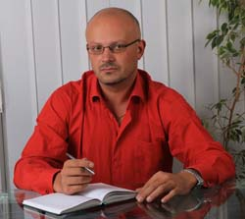
on the photo: Artem Timchenko www.ruasdvocat.com
- 17 March 2014, Dmitry N. from Kharkov was the witnessed how the representatives of "Right sector" had beat the woman in the street because she was talking on a cell phone in Russian.
- 17 March 2014 the first Deputy Chairman of the Ukrainian Parliament Committee of the fight against organized crime and corruption, G. Moskal said that 20 unidentified activists of "Euromaidan", the supporters "Right Sector" with Kalashnikov rifles and the pistols stormed the residential building of the company "Ukrkomplekt Plus " in village Kobtsy of Vasilkovskiy district of Kyiv region. The building were under protection of the State Security Service of Vasilkovskiy police department. The staff of State Security Service and the task force of Vasilkovskiy police department went on a call. But the representatives of the bodies until morning drank with criminals. Then the law enforcement officers left the building. The police did not response of the complaints, which were wrote by the owners of the building. http://svpressa.ru/society/article/83751/
- In March 2014, the deputy of Luhansk regional council Arsen Klinchaev was detained, because he had supported the holding of the referendum on self-determination of the Lugansk region and the status of the Russian language. The deputy of Ukraine Oleg Lyashko participated in the detention and arrest of the deputy Klinchaev. The evidence of the participation of Oleg Lyashko is the video, which fixed, that Oleg Lyashko put face down Arsen Klinchaev. Then Arsen Klinchaev was sent in Kiev.
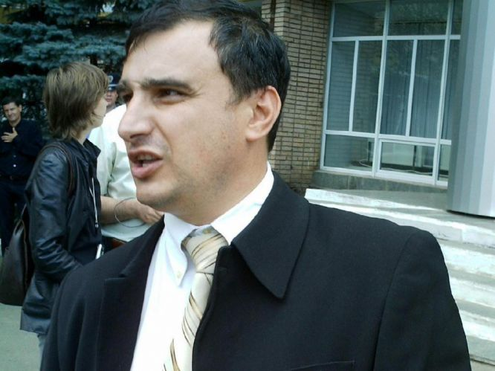
on the photo Arsen Klinchaev www.rusadvocat.com
59.18 March 2014 the group of the deputies of the Parliament of Ukraine, the MPs of the party “Svoboda” headed by deputy Miroshnichenko and famous actor Benyuk (National Artist of Ukraine) arrived to the office of the First National Channel of Ukraine (NTU) and forced the director of the channel A . Panteleimonov to write the resignation letter. The director of the channel A. Panteleimonov, has commented the incident later in the broadcast, and he said, that the deputies had "a long and annoying conversation"with him. Footage were posted on the Internet and show that deputy Miroshnichenko beat A. Panteleimon on the face and head. He was punished by Miroshnichenko for the demonstration of the address of the President of the Russia to Federal Assembly about Crimea: Miroshnichenko considered it "not patriotic." Miroshnichenko called A. Panteleimonov "Moskaliuka" and constantly reminded him that his channel allegedly lied about the situation on Maidan. http://flb.ru/info/57435.html http://za.zubr.in.ua/2014/03/24/25104/
60. 18 March 2014 the staff of the regional television in Chernigov were subjected to pressure. Several activists of “Right sector”, who were armed with grenades and with the edged weapons, stormed the building, blocked most of the premises and demanded the general director to resign. The reason - "an accomplice of the old regime." http://rusdozor.ru/2014/04/02/fakty-kriminalnogo-i-pravovogo-bespredela-radikalov-i-boevikov-na-ukraine/
61. 19 March 2014 in Vinnitsa the group of ultra-right members of the so-called People's Tribunal rudely demanded that the chief of the regional children's hospital T. Antonets voluntarily to resign because she publicly renounced "Party of Regions" and condemned "crime the previous government". The radicals said that in case of disobedience she will face with the reprisal "under the laws of harsh revolutionary time." http://www.youtube.com/watch?feature=player_embedded&v=IAcIFK74zYc
62. 20 March 2014 the group of representatives of the "Right sector" attacked the Hungarian students, who arrived on a tourist trip in the Carpathians from the Hungarian city Miikolts.
63. 20 March 2014 the armed representatives of the "Right sector" broke during the meeting of the Hungarian Council in Beregovo Transcarpathian region and beat the participants. http://novorossy.ru/news/news_post/prava-chelovekov
64. 20 March 2014 the ethnic Czechs, who are living in Volyn and Zhytomyr regions (according to unofficial data in Ukraine live from 10 to 20 thousand Czechs), appealed to the authorities of the Czech Republic with a request for repatriation. The Chairman of the Volyn Czechs Association E. Snidevich said: "We are afraid for their lives. There are bandits who called themselves "self-defense units." Ahead there is nothing good".
65. 20 March 2014 was published the video about the activity of the members of the organization "Right sector", where the radicals stormed the prosecutor's offices in Odessa and demanded that law enforcement officers "decided or they are with Ukrainians or they are with the occupiers."
66. 23 March 2014 in Kiev the representatives of the so-called 11th hundreds of self-defense ("Right sector") was an attempt to seize the building, which are the houses the Russian Centre of Science and Culture and the representation of Rossotrudnichestvo. The group of 12 men armed with metal poles (head of the attackers was armed with a gun), demanded the immediate release of the building, because it must be confiscated in retaliation with the situation in Crimea, and here will be located the "representation of the self-defense of Pechersky district." All the attempts to explain them, that the building is not the property of Russian authorities and only leased from the Ukrainian authorities have failed. Moreover, the attackers took the keys from the guard and stole the car of Rossotrudnichestvo.
http://www.politnavigator.net/rossotrudnichestvo-zayavlyaet-o-popytke-zakhvata-predstavitelstva-v-kieve.html
67. 24 March 2014 in Zaporizhia several dozen of the representatives of "Right Sector", armed with sticks, stones and iron bars attacked the participants of the "Auto rally of the friendship Melitopol-Zaporozhye." People were beaten, cars were damaged http://www.vesti.ru/doc.html?id=1406181&tid=105474 http://www.novoross.info/happens/24345-evronacisty-napali-na-avtoprobeg-druzhby-v-zaporozhe-video.html
68. 26 March 2014 in Kirovograd region the representatives of the "People's Parliament", the representatives of the "Right sector" and members of "Svoboda" attacked the chairman of the Ulyanovsk Central Hospital A. Tkalenko. The radicals tried to beat Tkalenko in his office . The "guilt" of the doctor was in his political views (he was the member of the "Party of Regions" and supported the previous government). http://pressa.tv/dtp/26692-napadenie-na-glavvracha-ulyanovskoy-crb-g-ulyanovka-kirovogradskoy-oblasti-ukraina.html
69. 30 March 2014 in Lugansk the representatives of "Right Sector" attacked the tent camp of the activists of "Lugansk Guard." Opponents of the "New Kiev authorities" were beaten by the bits, their tents were broken down. Several victims from among the activists’ camp were taken to hospital with significant head injuries and limb. The situation was not far from the police office, but the police preferred not to intervene. http://www.nakanune.ru/news/2014/3/30/22346805/
70. 31 March 2014 the Department of Health in Kiev said that during the riots in the capital of Ukraine suffered 1 608 people, 129 of them remain in hospitals, 103 people were killed. http://rian.com.ua/incidents/20140331/342494662.html
71. The residents of Transnistria reported about the transfer of the Ukrainian nationalist groups "Right sector" to the border, as well as the tense situation on the borders of Transnistria and complication of the border crossing for residents of Transnistria. The locals feared the discrimination and persecution on ethnic and linguistic grounds, the threat of ethnic cleansing by the Moldovan and Ukrainian nationalist groups. The tension escalated in Transcarpathia in connection with the growth of nationalist sentiment in the Ukraine. The residents of Transcarpathia reported that they were subjected to pressure by Ukrainian nationalists who refuse to recognize the Rusyns as a distinct people. Kiev authorities pursued a policy of ignoring the problem of Rusyns, and refused to conduct any negotiations on the status of Rusyns, preferring a policy of violence and intimidation that has created a situation of ethnic tensions and the threat of ethnic cleansing against the Ruthenians, despite the willingness of Rusyns for dialogue and cooperation. www.rusadvocat.com
72. At this time in Ukraine were formed the so-called punitive battalions nationalists "Dnepr", "Donbass" and "Slobojanschina", consisting of supporters of the "Right sector." Their tasks included the execution of military orders of the Kiev authorities instead of Ukrainian troops and special forces troops who refused to participate in punitive operations against dissidents and the Russian-speaking people. The nationalistic tension escalated in Kyiv. The local TV was censored, the information in the Ukrainian media was presented at an angle of national superiority over the Russian and other peoples living to the east of Ukraine and outside Europe. All this has affected both the mood in Kyiv and Ukraine. The Kiev authorities actively pursued a policy on debunking exploits fighters against fascism during the Second World War, and the glorification of Nazi Germany, reducing the negative image of fascism. The Ukrainian mass media disseminated the information, which deliberately distorted the information about the Second World War, where in relation to the Soviet soldiers, fighters against fascism sounded the slander. The image of the warrior-liberator continued to discredit, but the facts of the crimes of the Nazis, for example, the massacre at Babi Yar, the mass extermination of Jews in Ukraine and actively participate in the division of the OUN were not condemned. www.rusadvocat.com
73. 25 April 2014 the leading Russian mass media addressed the special statement to international organizations, including the UN, UNESCO and the OSCE, with the requirement to protect the professional rights of Russian journalists, who are working in Ukraine. The appeal was signed by representatives of RTR, NTV, REN TV, "First Channel", Russia Today TV channel and holding News Media. The leading Russian mass media pay attention that against Russian journalists, who are performing the professional duty during the news coverage in Ukraine, began a campaign by new Kiev government, which prevents the journalists in their work. According to media executives, glaring instances of violation of civil liberties occur almost daily in the Donetsk, Lugansk, Kharkov, Dnepropetrovsk and other regions of Ukraine. Reporters received death threats and violence if they continue their professional activities in Ukraine, followed, their phones tapped, put on his knees, beaten during arrest and illegally deported from Ukraine. Since April 2014 Ukraine the cases of the illegal treatment with representatives of the Russian media become frequent. So, 25 April 2014 the SSU in Donetsk were roughly arrested and then deported journalists from Russian mass media LifeNews Julia Snapper and Mikhail Pudovkin. In Mariupol the journalists Christina Babaeva and Maria Povalyaeva during an editorial assignment were detained by officers of the Ukrainian police. Christina was kept more than 18 hours in the district police department, where she was interrogated by SSU, after which the journalists were freed. The representive of the program "Central Television" Stepan Chirich was detained in Ukraine. The journalist of the NTV channel were charged for the using of the special equipment - a miniature video camera.
16 April 2014 the special correspondent of "News" Eugene Reshetnev was detained by the SSU and spent several hours locked up in the dark, after which he was freed.
The broadcasting of four Russian television channels "News" / "Russia 24", "Channel", "RTR Planeta" and "NTV-Mir" was stopped in Ukraine. The new Ukrainian authorities began the suppression on the Russian television in March 2014, when the National Council for Radio and Television recommended to the providers to stop broadcasting of the major Russian channels. The decision was motivated by "the need to ensure the information security of the country." The Russian Foreign Ministry expressed its attitude to restrict broadcasts and actual censorship, according to Russian Foreign Minister Sergei Lavrov, the prohibition of the broadcasting of Russian TV channels in Ukraine was a serious violation of human rights.
It is necessary to focus the attention on the event, which illustrates the situation in Ukraine: 27 April 2014 in Lviv was held the march, timed to the 69-th anniversary of the Ukrainian Insurgent Army and punitive police detachments SS "Galicia". On the same day the Kiev authorities declared the abolition of the march in the Victory Day on May 9.
It is indicative the situation of the civilian population and Ukrainian military service.
In Kharkov, according to the information of the local residents, "Right sector", began the "address terror", which consisted in the fact that the nationalists, who called themselves "black men", visited the houses of dissidents, who are not agree with new Kiev authorities, and conducted the "conversation" with people: the nationalists publicly stated that a database of addresses and phone numbers of members of pro-Russian demonstrations, and promised to "talk" to people as long as Ukraine does not remain dissatisfied with the new Kiev authorities.
In Kharkov began the mass beatings of dissidents and the Russian-speaking population: Kiev authorities used the nationalist football fans in the clashes against dissidents. The Ukrainian businessmen who refused to support the "Right sectors" reported: the nationalists began the raider attacks, the owners reported, that they forced to send their families abroad, while they are stay to protect the business from the attack. The Ukrainian troops reported, that during the general mobilization the distribution of the male population mobilized carried out strictly on the basis of nationality: transfer of the Russian-speaking male population of the eastern part of Ukraine's western regions and in Kiev, while the south and east of Ukraine sent to supporters of the "Right sector" and the male population of the Western Ukraine.
10 April 2014 on the day of the 70-th anniversary of the liberation of Odessa from fascist invaders World War II veterans were attacked by neo-Nazis "Right sector", threw eggs the defenders of Odessa and a monument to the Unknown Sailor. www.rusadvocat.com
74. 14 April 2014 the Russian human rights defenders have reported about the complaints from residents of Ukraine. People reported about the egregious human rights violations, discrimination and raider attacks. People, in particular, complained about the raider seizure of property and property by the representatives of 'Right sector "and other nationalist groups. Men were forced to engage in "partisan" groups, as well as at his own expense to buy weapons, which is commercially available. http://www.ntv.ru/novosti/906416/#ixzz3En0Uq2Fp
75. As the residents of Kiev, Kharkov, Odessa reported, that become frequent the raids targeted by "Right sector" against Russian-speaking population, people who oppose the nationalism and fascism in Ukraine and current Kiev authorities . Also, according to residents, the activists were subjected to beatings.
76. The deputy of Ukraine, the presidential candidate Oleg Tsarev 15 April 2014 went into the street, where he was beaten by the representatives of the "Right sector" http://lenta.ru/news/2014/04/15/tsarev/
77. 15 April 2014 the "Right sector" suffered the presidential candidate of the "Party of Regions" Mikhail Dobkin: politic was conducted through the “corridor of shame”, pouring green paint and sprinkle with flour. http://www.topnews.ru/news_id_67083.html, http://www.fontanka.ru/2014/04/15/097/, http://lenta.ru/news/2014/04/15/tsarev
78. 19 April 2014 in Kiev the head of "Faithful Cossacks" Alex Selivanov was beaten by the group of people, who stopped him in the street, the men introduced themselves as employees of the SSU and beat the activist. Alex Selivanov was hospitalized. http://rumol.org/2014/04/21/aleksej-selivanov-ne-zapugaete/
79. 25 April 2014 in Kiev was held the exhibition "Caution, Russians!", which was organized by people, who call themselves the Ukrainian intellectuals. The essence of the installation, that are Russians were presented as the uneducated alcoholics. The performers are placed in the cells in which are not recommended to feed them, talk with them, etc., ie, people were compared with animals. http://www.mk.ru/politics/2014/04/27/v-kieve-otkryilas-vyistavka-ostorozhno-russkie.html
80. In Nikolaev was held the campaign of intimidation and physical elimination of opponents of the new Kiev authorities: first shooting was broken up by pro-Russian camp, and then the leaders of the Antimaidan got the "last warning" – the Molotov cocktail at the doorstep. The leader of the Nikolaev regional organization of the party "Russian bloc" Yevgeny Bondarenko found at the door a bottle, like a "Molotov cocktail". Bottle went pungent smell of gasoline in it were inserted red and black ribbon. At the scene, Russian activist called the police and journalists.
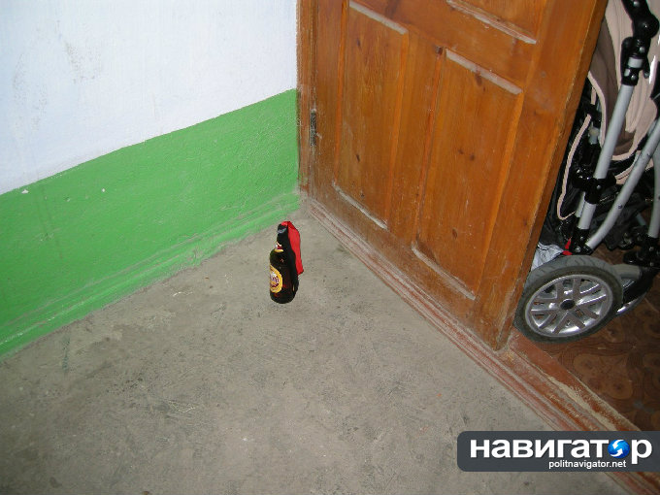
In the night from Saturday to Sunday, from 26 to 27 April the activist of the Antimaidan Dmitry Getmantsev, who were under house arrest, found the bottle with a note and the demolition pack near the private house (to the place where he used to park the car). The note refinement - the "last warning". And on Sunday, April 27 note with threats received the activist of the Antimaidan Tatiana Abramova.
http://www.politnavigator.net/poslednee-preduprezhdenie-protivnikam-novojj-ukrainskojj-vlasti-prigrozili-koktejjlyami-molotova.html http://www.youtube.com/watch?feature=player_embedded&v=UtvpwI3RS4E
81. In Dnepropetrovsk on Wednesday night 21 May 2014, the armed representatives of the "Right sector" barraged by "Molotov cocktails" the house of the deputy of the Parliament of Ukraine, leader of the "South-East of Ukraine" Oleg Tsarev. The attackers made the film on camera how the house burned. The local police confirmed that the group of 8-9 people had entered the territory of the Tsarev's house and threatened reprisals against the guard, set fire in the basement of the garage and the car with the help of a flammable liquid. After the incident, near the house of parliamentarian was found a lot of spent cartridges. http://diver-sant.ru/uanews/45898-v-dnepropetrovske-zabrosali-kokteylyami-molotova-dom-olega-careva.html
82. 28 May 2014 the mass media have reported about the shelling of Slaviansk. https://www.youtube.com/watch?v=wYQBGanK2mM&feature=player_detailpage
83. 29 May 2014 the Ukrainian security forces used against militias in Slavyansk and Kramatorsk artillery, aviation and multiple rocket launchers. In Slavyansk were destroyed the school and kindergarten. The Ukrainian army launched a full-scale bombardment of the cities in the east. According to the agency, as part of the "anti-terrorist operation" (ATO) Kramatorsk and Slavyansk are under attack of the aircraft, artillery and multiple rocket launchers "Grad". http://russian.rt.com/article/34121#ixzz3EmwFxSZM
84. One of the groups, which was persecuted by the current Kiev authorities were the representatives and parishioners of the Russian Orthodox Church. Thus, according to the information from human rights defenders and residents of Ukraine, the neo-Nazi attacked the religious objects, persecuted parishioners and representatives of Russian Orthodox Church. The residents have reported about the robberies religious objects, about the shelling the cathedrals and temples by the National Guard, which often resulting to the human deaths, the attacks committed in during the religious rites. Only in June 2014 on the territory of south-eastern Ukraine, according to local residents, were shot Alexander Nevsky Cathedral, a few times under fire, including and during the truce declared by Peter Poroshenko. Also were shot the Temple Reigning Mother of God; Holy Spirit temple; Church of St. Seraphim of Sarov; Resurrection Church. In the city Kherson, after the statements by activists of Euromaidan, who were against the existence in the church of St. Varsonofy Kherson, confessor, the temple was set on fire.
85. One of the most high-profile acts of vandalism is the attempts to seize the building of Kiev Pechersk Lavra in Kiev, 22 June 2014. In addition, was reported about the arsons of the churches in different regions.
86. The persecution carried out against the priests, abbots. For example, in the Luhansk region was arrested the rector of St. Nicholas Church in Novoaydar the Archpriest Vladimir Maretsky, who was accused of organizing armed attacks on polling stations in the area Novoaydarsky Luhansk region. The priest is in jail, and the previously reported torture of a priest. The wife of the abbot went to Moscow with children.
The priest of the Diocese of Lugansk the Archpriest Maxim Volynets was forced to leave the area and move to the suburbs with his family. Ukraine left the Secretary of the Odessa diocese Archpriest Andrei Novikov, head of religious education, catechesis and missionary work of the Odessa diocese Archpriest Oleg Mocreac and famous Kiev priest Archpriest Andrei Tkachev.
87. There have been the reports from members of the LGBT community in Ukraine that participated in LGBT events designed to demonstrate the absence of discrimination in the neo-Nazi Kiev, the only one way to survive for LGBT activists and their organizations, for LGBT, who did not take place in any organization, but about whose the sexual orientation is known. Thus, under the pressure and threats was launched in Kiev information campaign to make during the week LGBT advocate and support the unity of Ukraine Kiev authorities to express their superiority over the people of Russia, which is called in the statements of LGBT people in Ukraine, "the Russian provocateurs" or "padded jackets ". In May 2014 the mass media reported, that in Solomenskiy district of Kiev near the entrance of the house was shot 43-year-old entrepreneur and an active participant in the Maidan Alexandra Tolstoy, who is a former owner of one of the first in Ukraine gay -club "Scoop", in force from 2001 to 2005. http://upogau.org/ru/inform/uanews/uanews_1039.html.
The gay-club Lipstick in Kiev has undergone seven attacks. http://upogau.org/ru/inform/uanews/uanews_1203.html
88. 12 June 2014 the Minister of Defense of Ukraine issued a statement, that all the inhabitants of New Russia, including women, after the capture of the rebel towns and shot will be placed in a concentration camps and after checking evicted from their homeland for various regions of Ukraine. http://www.politonline.ru/rssArticle/21661651.html http://www.youtube.com/watch?feature=player_embedded&v=eGZLUxtUnlQ
89. 12 June 2014 the human right defenders got the information about the bombing of village Semenovka with using of the phosphorus bombs. http://www.youtube.com/watch?v=V4zX8AzidOE&feature=player_detailpage
http://www.rg.ru/2014/06/12/semenovka-anons.html
90. 13 June 2014 the village Makarovo of Luhansk region was fired from mortars Ukrainian army; hit home the civilian population. http://www.youtube.com/watch?feature=player_detailpage&v=z6p5GAk0lSU
91. 14 June 2014 the aggressive crowd of citizens and representatives of the "Right sector" laid siege to the building of the Russian Embassy in Kiev with the staff, who located there. The departure from the territory of a diplomatic mission was blocked; perimeter decomposed tires, and the building threw smoke bombs. The protesters removed the national flag of the Russian Federation with the flagpole. In addition, the crowd turned several cars with diplomatic plates, and threw stones at the windows with the dismantled bridge. "All the windows in the building are broken," - said the head of the press service of the Russian Embassy in Kiev, Oleg Grishin. In the crowd there were calls to burn the building. All the exits from the building were blocked by protesters. http://www.regnum.ru/news/polit/1813886.html#ixzz3EmmRXdmd
92. 15 June 2014 the protesters outside the Russian Embassy in Kiev thrown into its territory "Molotov cocktail". The firefighters put out the fire. The person, who acted as the Foreign Minister and Minister of Interior arrived to the protesters to conduct negotiations on the Saturday incident, when the territory of the embassy was stoned. http://www.interfax.ru/world/380919
93. 22 June 2014 the activists of the "Right sector" attacked the parishioners under the walls of Kiev-Pechersk Lavra, beat policemen. http://www.youtube.com/watch?feature=player_embedded&v=KaiC0awbLFo
http://ukraina.ru/news/20140622/1009566749.html
94. 26 June 2014 several hundred activists of the "Right sector" and the Social-National Assembly stormed the hotel "Tourist" in the assembly hall where the congress Federation of Trade Unions of Ukraine. Storm troopers did not hide their affiliation with neo-Nazi organizations; against the police used tear gas, broke the door of the hotel, carried out a storm the building. http://www.youtube.com/watch?v=1lVfsbLH5CE&feature=player_detailpage
95. 28 June 2014 in Kiev was held the performance, which was aimed at ridiculing of the the values of the USSR, the Russian way of life, the humiliation of the elderly, veterans, humiliation and insult people in Russia, people, who was born in the USSR. Russians were presented in the performance "square quilted jacket", their image is created with using of the paper bags placed over the head, voice changes, shouting slogans insulting the Russians. The action took place near the Russian embassy in Kiev.
https://www.youtube.com/watch?v=DRgKLJhZEKE&feature=player_detailpage
96. 11 July 2014 was detained the mayor of city Slaviansk Nelly Shtepa, which has repeatedly been beaten http://www.ntv.ru/novosti/1240056/
97. 19 August 2014 in Lugansk region punishers taunted the villagers of Novosvetlovka. The representatives of Nation Guard of Ukraine had forced several people to dig the trenches. Then people were locked up in the church and then the radicals mined the church with people. About the incident told to media LifeNews the spokesman of the People's Republic of Lugansk Vladimir Inogorodsky. The Ukrainian army and foreign mercenaries rounded up people during the day and last night forced to build a fortified area around the church. Persons who disagree to work were publicly shot. http://lifenews.ru/news/138648
98. 20 August 2014 in the Internet were published the videos and photos of torture of the Ukrainians by the side of the representatives of the National Guard of Ukraine. 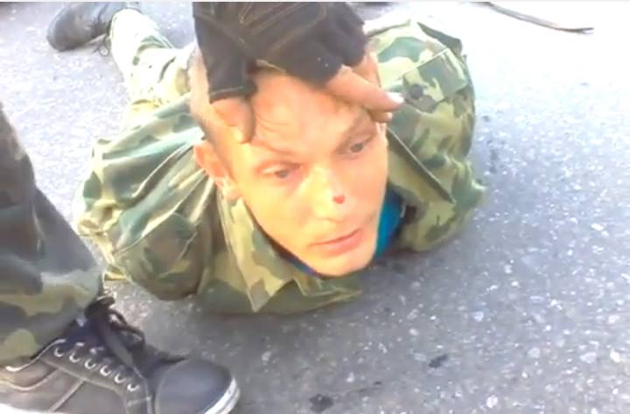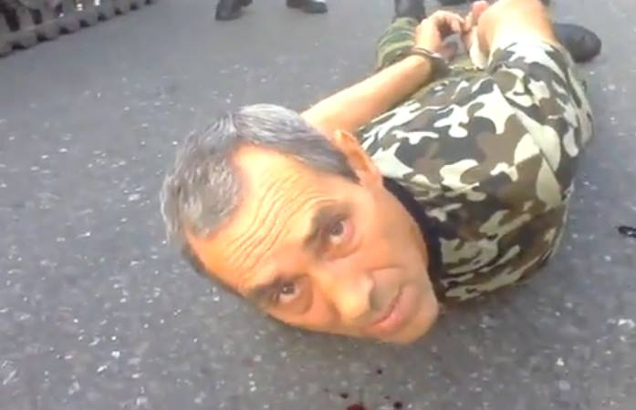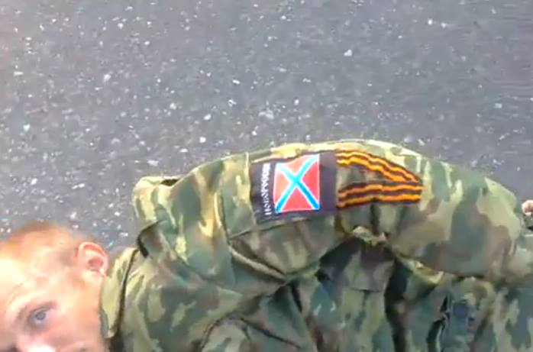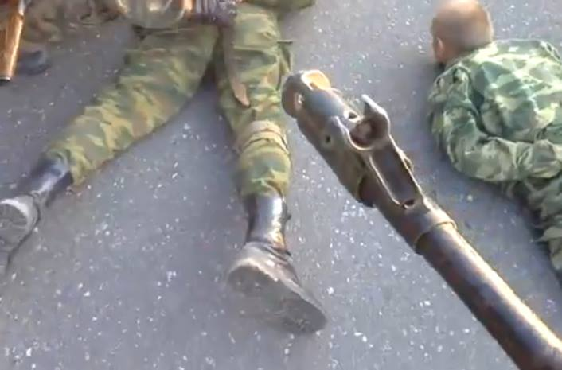
https://www.youtube.com/watch?v=XK-gknr6uO8&feature=youtu.be
99. 17 September 2014 the mass media published the information about the pressure and threats against the famous Russian singer Sofia Rotaru. According to the portal SUPER, the family Rotaru received threats from the "Right sector". In particular, the representatives of the "Right Sector" visited 63-year-old Lydia Rotaru, who living in Kiev, the participants of "Right Sector" proposed the family to "decide" on which side Rotaru is and which policy she supports. Lydia stressed, that the men directly had threatened the whole family and proposed to the family to leave Ukraine. Art-director of Sofia Rotaru Sergei Lavrov said that shocked of the situation. According to him, Sophia Rotaru experienced the fear for the family. http://www.pravda.ru/news/world/formerussr/ukraine/17-09-2014/1226813-rotaru-0/
100. 28 September 2014 in Kharkov one man has suffered during the demolition of the monument to Lenin. This man tried to prevent the demolition of the monument. The man was beaten by representatives of the "Right sector", the attackers put him on his knees, then they kicked him in the face and head.
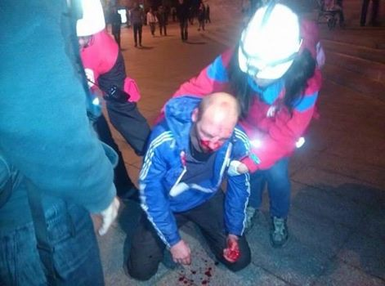
101. 29 September 2014 the mass media published the information about the victims of the rape, who been raped by the representatives of "Right sector." It is the information about the multiple gang rapes underage girls 12-14 years in Donetsk region. http://my.mail.ru/mail/ne_krasivaya2011/video/5078/5084.html
102. 29 September 2014 the residents of Kharkov who were disagree with the demolition of the monument to Lenin, urged the representatives of the "Right sector," who were gathered at Freedom Square, to stop the destruction of the monument. Their call met the aggressive reaction. Young people in masks and camouflage suits beat the opposition, people who not supported the demolition of the monument http://russian.rt.com/article/52170#ixzz3EmY7EKZc
http://www.youtube.com/watch?feature=player_embedded&v=4tX2P5n5MKU
103. 30 September 2014 mass media published the video footage confirming the beating of people during the rally of demolishing of the monument of Lenin in Kharkiv. The opponents of the demolition were beaten. According to official information of the mass media there were 5 victims. The police did not reacted on the attack and beating of people. http://tvzvezda.ru/news/vstrane_i_mire/content/201409300053-gjv4.htm
104. 30 September 2014 the representatives of the "Right sector" beat the deputy Nestor Shufrich in Odessa. Nestor Shufrich and his colleague Nikolai Skorik left the car on Shevchenko avenue near the building of the Odessa Regional State Administration and in the street they fell on the crowd of the supporters of EU-integration, who began to beat the deputy and his colleague. The guards safe the politicians and fired several shots into the air, but activists do not run away, and took away the protection of weapons, and then continued to beat deputies. The politicians left the street in the minibus. The state of policy was extremely heavy. The preliminary diagnosis - a concussion, closed head injury, broken nose. Among the attackers the witnesses recognized Sergei Gutsalyuk from “UDAR”. Also there were the activists of the "Right sector", the representatives of the "self-defense of Maidan". http://rusvesna.su/news/1412082882
VIII. Enforced or Involuntary Disappearances
The authors of the report consider the enforced or involuntary disappearances as a crime, when the government bodies or persons acting under the protection of the state (for example, military, police, civilian patrols or guards) abduct people. The authors of the report emphasize that the enforced disappearances in all cases of disappearances are include the aspect of human suffering. The enforced or involuntary disappearances are the crimes that is committed by individuals (individual responsibility), as well as a situation where the state is not fulfilling its duties.
The essence of the enforced disappearance is that state bodies detained the human, and later claimed that they knew nothing about this arrest. The enforced disappearance may be divided into three elements. The enforced disappearance took place if: the person is detained; persons, who acting on behalf of the state, which subsequently deny it or hide the truth.
The cases, when the opposition activists detained, tortured in secret locations, and a few days later released are considered as the enforced or involuntary disappearances. The victims and their families often perceive such cases as the torture, but they are also the enforced disappearances, because during the imprisonment took place the hiding of the information.
The signs of enforced or involuntary disappearances are the lack of information on the fate or whereabouts of the person cases when relatives reported that the human is in custody, but did not report its location and / or the circumstances of the detention. The message that the person has died in custody, but his remains were not returned to the family, is the disappearance.
It is necessary to distinguish the secret detention, which implies a content person in custody in a place that does not belong to an officially recognized place of detention. Examples of such places: the private house or an apartment a government official, the military camp, the secret prison or a secret room in the large building. The secret detention is different from enforced disappearance: the authorities recognize that the human was detained. http://www.ediec.org/uploads/media/Using_Law_against_Enforced_Disappearances_Russian.pdf
In this case, the authors of the report stress, that Ukraine has neither signed nor ratified the UN Convention for the Protection of All Persons from Enforced Disappearance, which entered into force on 23 December 2010.
The experts pay attention to the necessity of the ratification of the UN Convention by Ukraine in connection with the difficult situation involving the coerced and involuntary disappearances in the territory of Ukraine. It should be noted that the failure of the Convention of the United Nations leads to serious violations of human rights and in fact demonstrates the policy of the Ukrainian government on this issue.
105. 06 March 2014, People's Governor of Donbass Pavel Gubarev was arrested for his public statements about the necessity of the holding of a referendum about the self-determination of the Donetsk region. The location of Pavel Gubarev for an extended period of time remained unknown.
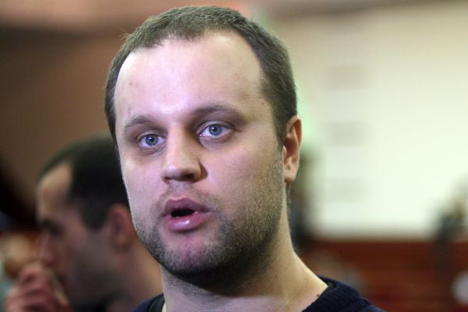

106. 06 March 2014 the information about the torture against People's governor of the Donetsk region Pavel Gubarev was published in the Ukrainian forum antifashist.com. According the information, Pavel Gubarev was detained by the Security Service of Ukraine. The reports stated that the doctors who are working in the prison of the SSU in Kiev, confirmed, that Pavel Gubarev was severely beaten and was in a coma. The medical possibilities were not enough, the staff of the SSU did not want the leakage of the information and banned to remove Pavel Gubarev for the getting of the professional medical care. This incident was hidden from society. Later the information about torture of the Pavel Gubarev was published in the portal "News Time", where was announced the reason of the torture: Pavel Gubarev was accused, that he allegedly work for Russian special services.
http://ruskline.ru/politnews/2014/03/20/pavla_gubareva_pytal_lichno_glava_mvd_ukrainy_arsen_avakov/ http://www.rg.ru/2014/04/26/gubarev-site-anons.html
107. 17 March 2014 in Odessa, the leader of "People's Alternatives", one of the leaders of Antimaidan Anton Davidchenko was arrested. Anton Davidchenko is one of the organizers of the rally in support of joining the Crimea to the Russian Federation. After the detention Anton Davidchenko was transferred by SSU from Odessa to Kiev. The location of Anton Davidchenko for a long time remained unknown.
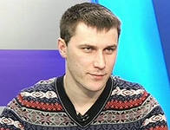
on the photo Anton Davidchenko www.rusadvocat.com
108. 19 March 2014 the journalist of the online edition "Segodnya.ru"
Alexey Khudyakov was kidnapped. 28 February 2014 in accordance to his an editorial assignment he was in Donetsk (during business trips it was prepared and published five articles and news items, in which he expressed critical views on radical pro-Nazi groups, and the "new government" in Kiev). A. Khudyakov was pushed into the car by masked men in the street. After that, he was handcuffed, on his head put on the black bag, the journalist was taken into the forest. One of the kidnappers introduced himself as an employee of the SSU, but refused to show any documents. A. Khudyakov subjected to threats and intimidation, including the directed threats to his life and the lives of his relatives. The journalist was forced to list the names of the relatives , who were listed in his phone. The kidnappers inspired him that he "misjudge the situation." Under the threats, A. Khudyakov was forced to read out a video camera unknown text in Ukrainian, also he signed the documents, that he is ready to work for the Security Service of Ukraine. In case of the disclosure of the situation the attackers threatened to kill him and his family. The Ukrainian SIM cards for mobile phones of A. Khudyakov were seized, memory cards for the phone were seized too, the photo and video and the address book on his phone were erased. The journalist was taken to the Russian border and was referred for the deportation. https://www.oprf.ru/press/news/2014/newsitem/24264

109. 18 May 2014 the employees of the Russian TV channel LifeNews Oleg Sidyakin and Marat Saychenko were kidnapped in Kramatorsk of Donetsk region by the members of the "National Guard," and handed over to the Security Service of Ukraine. The location of the journalists for a long time remained unknown. For a long time their exact whereabouts were not known. They were accused of "promoting terrorists": allegedly they transported in the car the portable air defense missile system. Officially, allegedly journalists were in Kiev in the detention center. But in fact, they were in "earthen pit" under the threat, that they will be killed. They were not allowed lawyers. The hands of journalists were tied up with rope, their legs were shook with duct tape. They were beaten in the head and in the groin. http://www.rg.ru/2014/05/26/journ.html
The international human rights organization Human Rights Watch called to the immediate release of the kidnapped journalists of Russian TV channel LifeNews Oleg Sidyakina and Marat Saychenko. http://www.rg.ru/2014/05/22/human-anons.html

110. 6 June 2014 the journalists of the Russian TV channel "Zvezda" Andrew Sushenkov cameraman and sound engineer Anton Malyshev were kidnapped near the district Bylbasovka. During the kidnapping of journalists "put on the head and balaclavas and made to kneel". Later, the “National Guard” of Ukraine reported that Russian journalists were transferred to the employees of the SSU in connection with the allegations of "observing and gathering information about the roadblock Ukrainian security services." http://www.regnum.ru/news/polit/1811856.html#ixzz3Emvmlb5R
These journalists were taken to a military helicopter to an unknown location, the journalists held two days without water in the cramped, stuffy room, in the sun and the temperature reached 50 degrees above zero. The representatives of the SSU tried by every possible way to find the information, that the journalists working for Russian special services. . http://www.rg.ru/2014/06/08/jurnalisti-site.html http://www.rg.ru/2014/06/09/plen-site.html

111. 18 June 2014 was published the information about the kidnapping of journalists of Russian channel "Zvezda" - Evgeny Davydov and Nikita Konashenkov. Evgeny Davydov and his colleague Nikita Konashenkov were captured by the representatives of the "Right sector". The kidnappers sent the text messages to the wife of Evgeny Davydov in the night: "You'll get your spouse in parts", "we cut off his legs." The kidnappers demanded money - 200 thousand dollars. During the abduction the journalists were wore the balaclavas, with the force they were pushed into a car and taken somewhere, then they were placed in the basement, where different persons constantly came with a gun and threatened to bury them in the morning, promised that "Moskali" will not leave this place alive. The journalists spent in the basement about an hour and a half. Then the journalists were placed in the car, because the kidnappers agreed to convey to someone the journalists $ 500 per head. The journalists were taken to the center of Dnepropetrovsk, out of the car, drove at gunpoint on the third floor of a building with a black and red flags of the "Right sector", as it turned out, on the ground floor were the room of the Security Service of Ukraine in Dnepropetrovsk. The journalists were questioned in the room, where the windows were closed by the cardboard sheets. The journalists were beaten by the silenced persons, then the journalists transferred into the room, where they got the paper with a pen. On the idea of kidnappers, the journalists had to write, what they do in Ukraine, the kidnappers came and watched what the journalists write and when something did not like to kidnappers, the journalists were beaten again and demanded to rewrite. The journalists had got the threat that they will be killed. Later, the answers of the journalists were recorded on the camera: during the "wrong" answers the camera is turned off and journalists were beaten again. Then the video recording was continued. The journalists were taken somewhere. The journalists were managed to find and pick up from captivity, and the doctors diagnosed Eugene the eardrum, both journalists had the hematoma, bruising all over his body.
http://www.rg.ru/2014/06/17/journalisti-site.html
112. On the night of 22 to 23 July 2014 four journalists, including freelance reporter for Russia Today, the citizen of the United Kingdom Graham Phillips and the operator of the news agency Anna-News were kidnapped in the combat zone in the east of Ukraine. It was established that journalists were held captive by the Ukrainian security services. http://www.rg.ru/2014/07/24/jurnalisti.html
113. 04 August 2014, three foreign journalists disappeared on the territory of Ukraine. The Ukrainian media expert Anatoly Shary explained about it in his video. The journalist of the channel "112 Ukraine" Roman Hnatiuk and two reporters, who are working for the Serbian and German editions, disappeared on the territory, which "controlled by representatives of the National Guard." http://tvzvezda.ru/news/vstrane_i_mire/content/201408041543-u9b1.htm
114. 26 August 2014 the freelance photojournalist and stringer French AFP Maxim Vasilenko and his colleague, correspondent of the edition "Crimean Telegraf" Eugeniya Koroleva were kidnapped by members of the Ukrainian "Right sector" in Donetsk region, the location of the journalists has long remained unknown. http://ria.ru/world/20140826/1021406562.html#ixzz3EkFtly2w http://ria.ru/world/20140826/1021406562.html
115. 08 September 2014 in mass media was published the interview with known writer and poet Yuri Yurchenko, who was kidnapped by the National Guard soldiers of Ukraine and had spent 24 days in captivity. The poet sat in an iron box, where he will be released only for beating. The writer was exchanged for three Ukrainian captured soldiers . As Yurchenko stressed, first week he was not fed and given water to drink, only beaten. During the beating the poet's left leg and rib were broken. http://lifenews.ru/mobile/news/140058
116. 16 September 2014 the interview with Simon Verdiyan was posted on YouTube. Simon Verdiyan was freed in a result of the exchange of prisoners, which took place on September 12 in Yasinovataya of the Donbas region. Simon Verdiyan talked about how he was kidnapped and what happened with him during his captivity the National Guard of Ukraine: Simon Verdiyan got the death threats, the charge of an empty gun to his head, he sat captive in a pit by the explosion, where he was constantly scared murder, then the prisoner was expecting the helicopter under the sun during the day, after sending the helicopter, Simon was took by the car to the place where he was to remain in captivity: after leaving the car, forced to the ground and crawl in handcuffs, then he was beaten, moved, hooking to floor of the car with handcuffs, 3 days he did not eat, did not sleep 3 days, Simon spoke about the constant beatings, promises to shoot. During the interrogation, the members of the National Guard of Ukraine beat him by the pistol about 2 hours. Simon Verdiyan had got the concussion and broken ribs. Simon Verdiyan said that those who are engaged in interrogations, receive the compensation from the Kiev authorities in the form of the apartments. Simon Verdiyan was all time without lawyer protection, he was not transferred to the detention center. The location of Simon Verdiyan was not known, but Simon Verdiyan got the threat, that his family will be killed. Simon Verdiyan was forced to record the video with the statement of the facts that did not have a place, but Verdiyan was agreed under the threat of deprivation of life. http://www.youtube.com/watch?v=bN6uJ2D86k8
117. 16 September 2014 in the mass media was published a statement of the Lugansk priest Archpriest Vladimir Moretsky, who was kidnapped in May 2014 and was a prisoner of the Ukrainian National Guard. According to the priest, he was brutally tortured and trapped - shot, broken bones, and beat not only on hands and feet, and rifle butts and all means at hand. According to the report, during the torture of people's hands were tied behind his back. Men were put a face to the wall and beat. http://rusvesna.su/news/1410869933

118. 18 September 2014 the stolen Stanislaw Stankievich told about the pits for the prisoners in Kramatorsk, where people sit in chains. Stankevich was kidnapped in 24 August 2014, he was tortured in Kramatorsk, on his body was burned a swastika by chain and knife and the word "separatist" on his chest, as he sat in the pit, said that new prisoners came on the chains. Near the pits was the minefield, where prisoners were driven out, under fire they were forced to walk through a minefield, among the captives was a lot of young girls. http://www.youtube.com/watch?v=bN6uJ2D86k8
119. 22 September 2014 was released the stolen correspondent of channel "First Crimean" Anna Mokhova, who was stolen 24 August 2014. She was in captivity of the Ukrainian secret service about a month. Anna Mokhova was accused of of illegally crossing ща the border of Ukraine "to execute the tasks of Russian special services." http://www.rg.ru/2014/09/22/reg-kfo/mohova-anons.html
120. 29 September 2014 was published the interview with the activist "Young Russia" Maria Kolyada, who was kidnapped by fighters of "Alpha" of the SSU. Maria Kolyada was accused of the espionage, reconnaissance and sabotage activities in Russia's favor. The stolen activist held in detention five months in solitary confinement. 15 April 2014 she was beaten by the men of the middle age about 40. She was beaten in the abdomen, chest, on average once a week she was taken to the investigator and from his office she was transferred to the department of counterintelligence. http://www.gazeta.ru/social/2014/09/29/6239581.shtml

IX. Extrajudicial executions
The authors of the report consider the extrajudicial executions as unlawful and deliberate killings carried out by order or by acquiescence of the government. The executors - the police or the army, in which structure creates a special unit output beyond the usual control system, or civilians acting jointly with government forces or with their support. The victims are members of the opposition, the oppressed sections of the population; they may be killed in prison, at home or in the street (in the course of military operations or to disperse a peaceful demonstration).
In 1989, the UN adopted the Principles on the Effective Prevention and Investigation of Extra-legal, Arbitrary and Summary Executions. This document, among other things, requires the investigation of all, without exception, extrajudicial killings and bring the perpetrators to justice and compensate the families of the victims.
UN Commission on Human Rights on extrajudicial, summary executions or arbitrary executions adopted at the 58th session in April 2002, and calls for governments on the need for effective measures to combat and eliminate the practice of extrajudicial, summary executions proper or arbitrary executions, which represent a flagrant violation of the inherent right to life.
121. 18 February 2014 the journalist of the newspaper "Vesti" Vyacheslav Veremiy was murdered in Kiev. The members of the neo-Nazi groups with bats and guns attacked the taxi in which he and his colleague IT-specialist Alex Limarenko returned home. The journalist, his colleague and the driver out of the car and they were severely beaten. The face of Limarenko was disfigured, Veremey was shot in the chest, from which he soon died.
122. According to the Union of Journalists of Ukraine, which was made in February 2014, violations of the rights of mass media workers in the "revolutionary events" were unprecedented. One journalist (V. Veremey) was killed, 167 media employers were injured and dozens suffered all kinds of attacks. The availability of the editorial certificate or the inscription "Press" on clothing does not protect against attacks and destruction of professional equipment.
123. 18 February 2014 the members of the "Right sector" seized the headquarters building of the "Party of Regions" in Kiev. Two men were brutally murdered. One of them were closed in the basement, which was thrown by "Molotov cocktail", man died of suffocation and burns. Another man smashed his head and dropped down the stairs. http://www.youtube.com/watch?v=WUVmvjfz2nA http://www.youtube.com/watch?v=NW3JB-ntF7g http://www.youtube.com/watch?v=MkRftMqFhvg
124. 09 March 2014 the representatives of the "Right sector" shot with a machine gun a local businessman E. Slonevskii in the cafe in the center of Kharkov. Also was killed another visitor, the waiter was injured. http://kp.ua/incidents/442765-ubyistvo-v-kharkove-kyller-rasstrelial-byznesmena-kotoryi-pomohal-ukhodyt-ot-nalohov

125. On the night of 15 March 2014 the members of the "Right sector" staged the massacre in Kharkiv, in which two people were killed, four - were injured. The journalists stressed, that the fighters were led by Andrei Beletsky, one of the leaders of the "Right sector." The information about his arrest there was no. Perhaps he could be released by the police with other rebel leaders. http://sevas-services.info/index.php?topic=3012.0#.VDLBoxZ9CZE
126. According to the residents of Slavyansk, 24 April 2014 the National Guard of Ukraine took Slavyansk in the surroundings and began to assault the city. 24 April 2014 first victim of the assault became peaceful unarmed resident of Slavyansk Lubenets Alexander, who was born in 1992. The killed in Slavyansk in April 2014: Sergei Rudenko, 53 years; Pavel Pavlenko, 42 years; Siganov Alexander, 23, was killed April 24, 2014 a sniper shot; Lubenets Alexander, 21 years old.

127. 28 April 2014 the mayor of Kharkov Gennady Kernes was injured while jogging: were punctured lung and liver. Kernes was taken to the city hospital for emergency care. The doctors ascertained the gunshot penetrating wound. http://www.unian.net/politics/912389-na-kernesa-soversheno-pokushenie-strelyali-v-spinu-na-porajenie-obnovlyaetsya.html http://korrespondent.net/ukraine/politics/3355501-pokushenye-na-kernesa-mera-podstrelyly-vo-vremia-probezhky
128. Odessa, 02 May 2014 at 15:00 the representatives of the "Right sector" and other nationalist organizations were going to organize a march "For the unity of Ukraine", which gathered in the center of Odessa at Cathedral Square, also attended and armed with bats and chains, many closed-masks persons, equipped with helmets and shields representatives of the “self-defense of Maidan”, members and supporters of the "Right sector." In addition to the slogan "For a United Ukraine!" and "Glory to Ukraine!" Attended the slogans of "Death to the enemies", "Moskalei on knives." http://timer.od.ua/news/storonniki_evromaydana_i_ul_tras_marshiruyut_po_odesse_vozmojni_besporyadki_translyatsiya_699.html
In addition, the representatives of the "Right sector" and “self-defense of Maidan” were armed with axes, wooden and metal sticks, and firearms. Some journalists reported, that among the representatives of the “Right sector” were the disguised law enforcement officers from the special battalions of the MIA "East" and "Storm", which were formed by the new government of Ukraine, also there were the fighters of the 14- th hundred of the “self-defense of Maidan”. According to the journalist, there were the fighters of the 3, 8 and 14-th hundreds of the “self-defense of Maidan”. In the streets were the members of the nationalist organizations from other cities of Ukraine: Nikolaev, Dnepropetrovsk, Vinnitsa, Zhitomir, Kherson, Donetsk. In total, according to data communicated news agency Odessit.ua, to Odessa on the eve of the event arrived 15 buses with pro-Ukrainian activists. The total number of the neo-Nazi groups, which arrived to Odessa before the march, according the journalists of the news agency Timer, appreciated from 300 to 700 people.
http://www.odessit.ua/news/odessa/28155-pravyy-sektor-iz-nikolaeva-ne-bez-gordosti-zayavil-o-svoem-uchastii-v-krovavoy-boyne-v-odesse.html
The clashes at Greek square
At approximately 13:30 on Alexandrovsky Prospect at the intersection with the Zhukovsky street began the collecting of the opponents of the pro-Ukrainian march. The backbone of this group was "Odessa squad", whose leaders were marked (above the elbow) by the red tape. At approximately 14:40 between the pro-Russian activists and a young man named Dennis was the verbal altercation occurred, over the fact that Dennis T. has made against the activists of Kulikovo field a few shots from a pneumatic gun. The gunman was arrested and handed over to the police officers.
Approximately about 15:30 pm the column of pro-Russian activists armed with shields, protective ammunition, bats, came out to the Greek square to oppose the march. On their hands were tied by St. George ribbons and bonnets of the red tape.
The clashes broke out at the entrance to the square. The number of supporters of federalization, according to an UNIAN correspondent, has reached 500. They began to build a makeshift barricade at the supermarket "Athena". The crowd of opponents with sticks and stones ran there. About 16:30 pm on the Greek square the "Right sector" and the representatives of other nationalist organizations began to pour «Molotov cocktails». During the further clashes in the street Deribasovskaya the opposing sides threw paving stones at each other and "Molotov cocktails". The representatives of the "Right sector" and nationalist organizations have stolen the fire engine, which arrived to the place of the clashes on call about the burning car. The Nazi threatened the driver. Also they tried to storm the fire station nearby. The stolen fire engine they began to be used as a battering ram to break through the barricades and break the enemy's lines of police cordon.
By 18 o'clock about thirty people of the opponents of the Ukrainian authorities stepped in shopping center "Athena", which located at the site of the collision, and took a position there. Most of the supporters of Euromaidan moved to Kulikovo field, a number of them blocked the shopping center "Athena", trying to capture had taken refuge the opponents.
The events at Kulikovo field
About 19 o'clock the representatives of "Right sector" and representatives of other nationalist organizations got to Kulikovo Field, where smashed and burned the campground of supporters of federalization, which was located near the House of Trade Unions. During the confrontation the "Right sector" used “Molotov cocktails”, pieces of paving stones, the shots were heard.
The fire in the House of Trade Unions
The forced from Kulikovo field the supporters of the federalization had taken refuge in the House of Trade Unions. According to eyewitnesses, in the House of Trade Unions were no any foreigners, no any people armed with guns; it was confirmed by the investigators later - according to the information of the investigators in the building was only traumatic weapon, there is no firearm weapon. The activists of the "Right sector" and other neo-Nazis pelted the building with “Molotov cocktails”, were shooting at the windows of the building.
During the confrontation, the "Right sector" began to set fire to the building. First were set fire the central doors, and then the hall of the first floor. The fire spread to several floors, it was due to delay the fire calculations. According to the survivors, the fire has gone from below, from the ground floor. According to some reports, even before the fire, the attackers were able to break into the building from the back door, located on the rear side of the building, seized the side corridors on the several floors.
According to the head of the main department of State Emergency Service of Ukraine in Odessa region Mr Bodelan, a large fire in the lobby of the building began, when the attackers managed to throw back a few burning automobile tire covers. According to Mr Bodelan, in the rescuing of people from the building involved fifty employees of SESU, who helped to get out of the building about 350 people.
Mr Bodelan argued, that firefighters arrived to the building on time, but the crowd in the square blocked the pass of the firefighters car to the building and prevented the firefighters in their work, trying to take away the car.
Part of the activists of the “Right sector” prevented the firefighters to carry out their work, more over the Nazi before the firefighters arrived did not let the supporters of federalization to leave the burning building, forced them to jump out of the windows, fired at the windows of the building and banned the evacuation of people, and beat those who tried to survive and jumped out the window. According to the description, which were published by BBC News with the reference to interview of the witness to Russian channel Russia Today: «Some people screamed "Die!", when people fell down." According to eyewitnesses, the attackers of the house of trade unions, who stormed the building and broke into the building killed people using the firearms and sticks, burned alive, suffocated. As the head of the SESU in Odessa region Vladimir Bodelan stressed, the representatives of the "Right sector" beat people, alive feared to leave the building and refused to get out. As a result, the survivors activists left the building, were gathered by the activists of the “Right sector” and other neo-Nazi organizations, were beaten and were taken to the police.
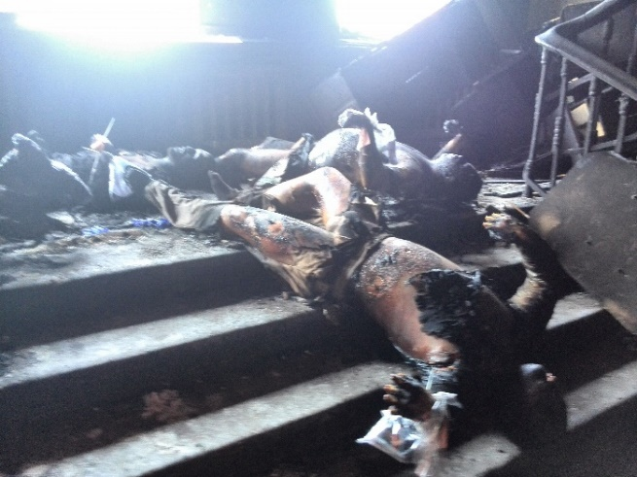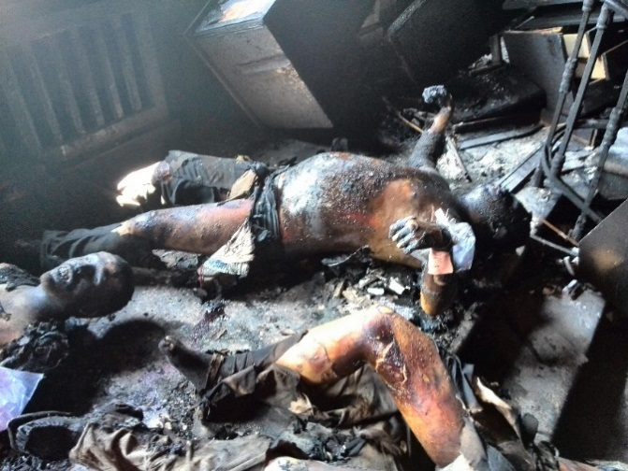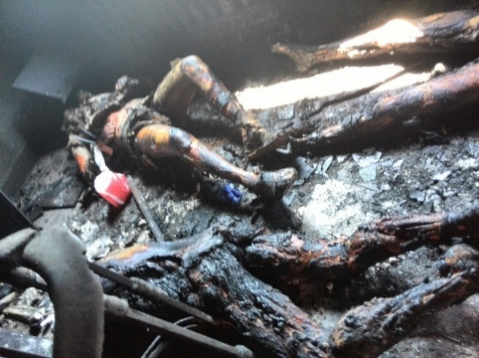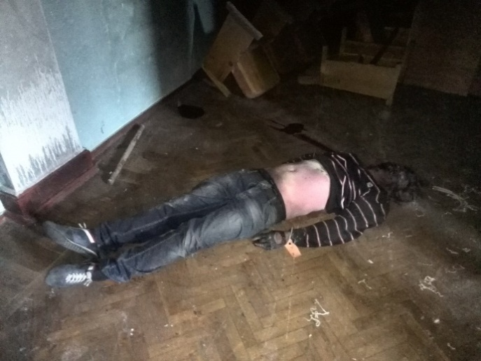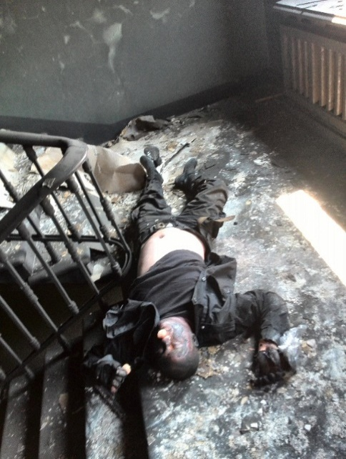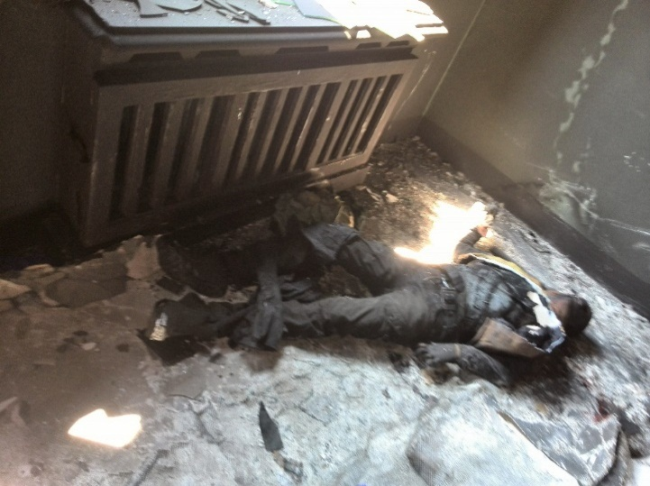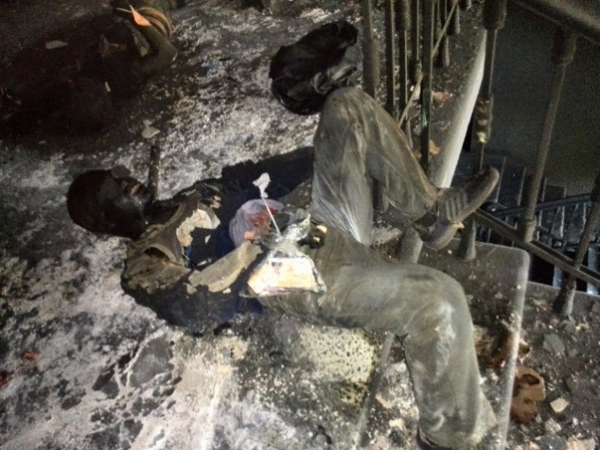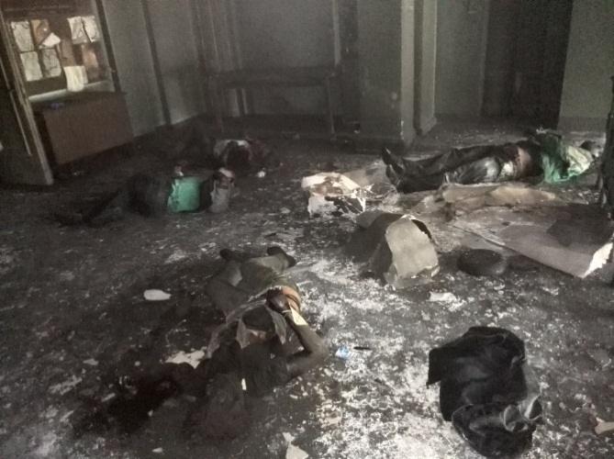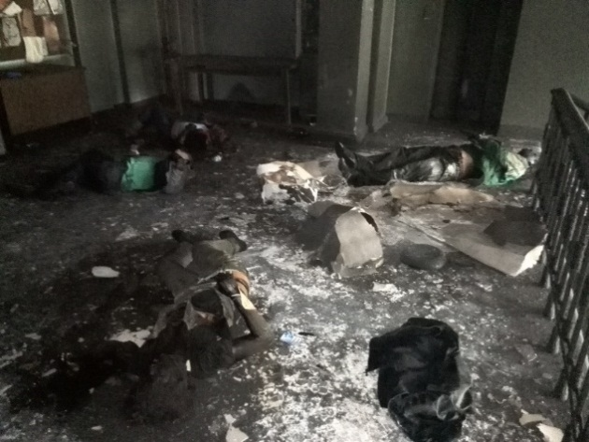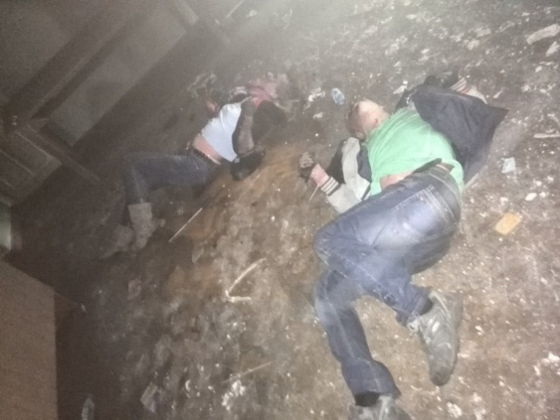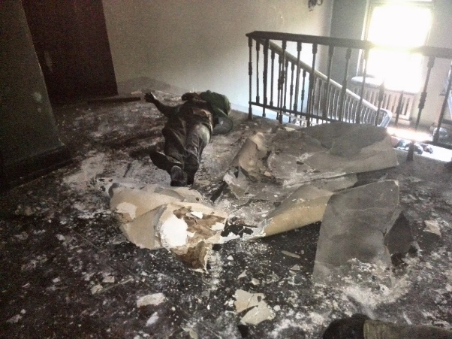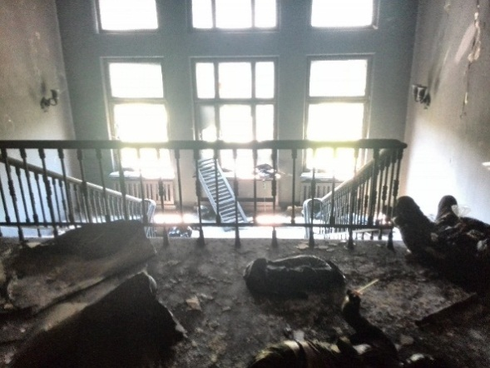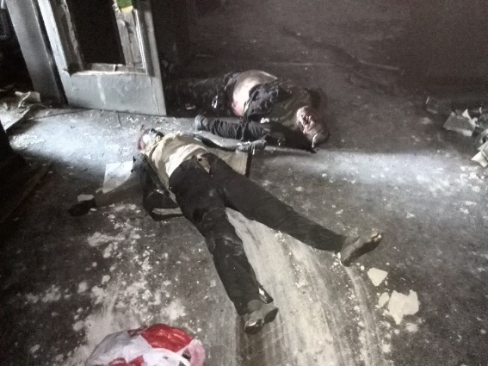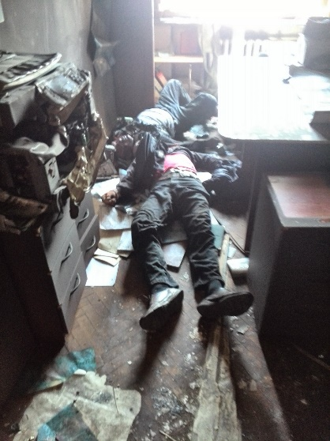
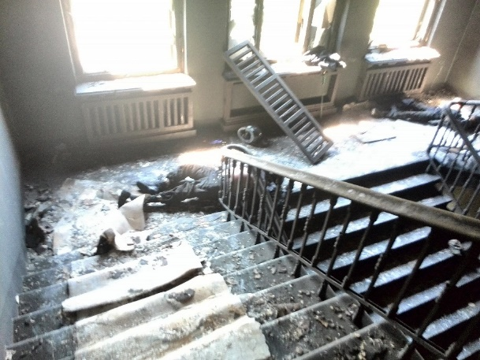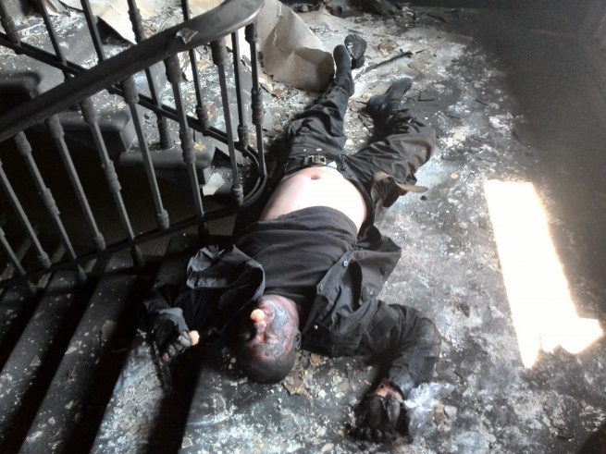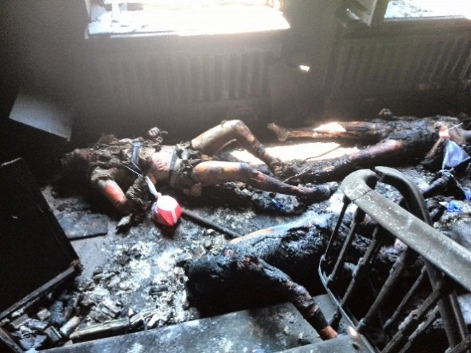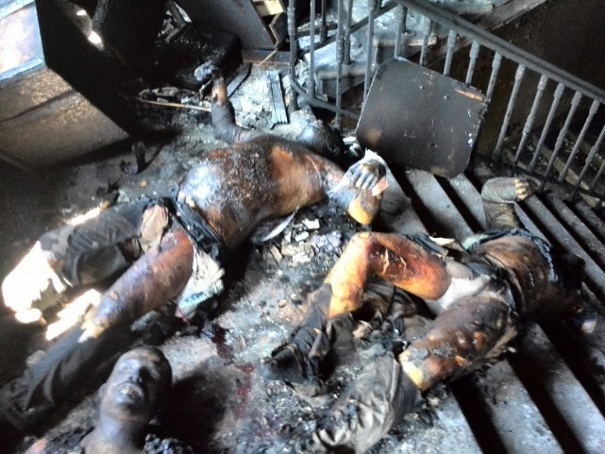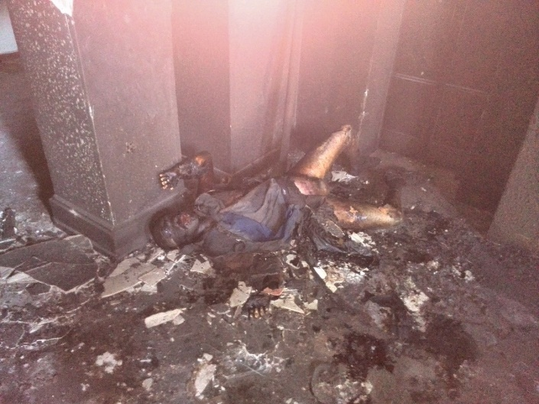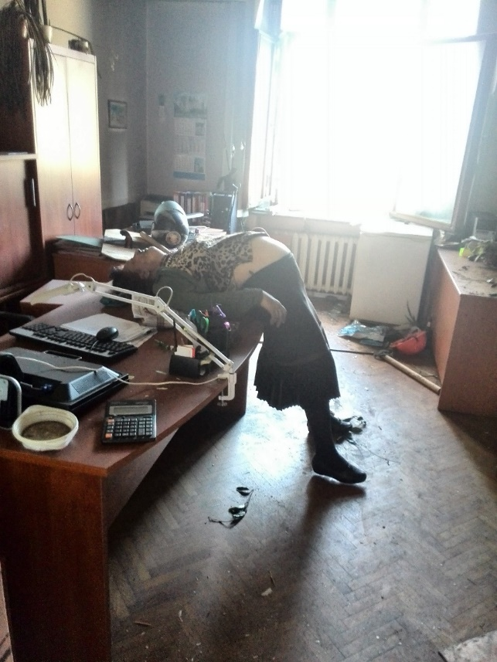
The photos of 03 May 2014, the author Alena Nikolaenko, the head of the organization "Tip of the large and foster families of Ukraine "Great motherland ".

Killed and injured during the events of 02 May 2014
Estimates of the number
On 14 May 2014 were confirmed 48 deaths during the clashes in Greek street (four were died on the spot and two in the hospital) and at Kulikovo field; 11 - fell out of the window of the House of Trade Unions (2 of them died in hospitals), 31 - were in the House of Trade Unions (1 of them died in the hospital).
On 5 May 2014 the total number of unaccounted were 45 people, from the discovery of the bodies 20 bodies were not identified. 43 bodies were identified - seven women; 32 people were poisoned by gas fumes and died from burns; 10 were killed herself during the jumping out of the windows; six died from gunshot wounds. The oldest victim was 70 years old, the youngest - 17. It was reported that among the dead was one pregnant woman, who were strangled by an electrical wire.
By 14:00 4 May 2014 according to the operational headquarters in the city of Odessa 226 persons appealed to the hospitals. 88 persona were hospitalized, including one teenager of 17 years. The number of "heavy" patients per day decreased from 40 to 26 people. City officials asked the citizens with a request to donate blood for the wounded. The victims, who were in the city hospital, had the following nature of injury: gunshot wounds - 13 people; burn Injuries - 8 persons; blunt trauma including traumatic brain - 53; stab injury - 7 persons; carbon monoxide poisoning - 13 people.
The assessment of the OSCE
The observers of the Organization for Security and Cooperation in Europe (OSCE), who examined the Odessa House of Trade Unions, came to the conclusion that "the damage from the fire spread through the corridors of the first and second floors". It was in the report of the mission for the 5 May 2014.
The document also includes the information, that the local authorities have informed the OSCE observers on the number of victims of the riots: "46 bodies were brought to the morgue, among them five people with gunshot wounds killed in clashes on Cathedral square." "According to the source CMM, most of the bodies have been identified, it is mainly the inhabitants of Odessa and neighboring regions", - said the report of the special monitoring mission of the OSCE.
According to observers, three days after the tragedy in Odessa, "the overall situation is assessed as tense."
The assessment of the United Nations
28 July 2014 the chairman of the UN monitoring mission Armen Harutyunyan during the presentation of a new report on the human rights situation in Ukraine, the UN monitoring mission has to be stated that the investigation into the events 02 May 2014 is almost not moving. In its report, the mission "regrets the lack of cooperation from the Ministry of Internal Affairs and Security Service at the central level."

129. The authors of this report focus on the text of an interview with the witness of events May 2, 2014 in Odessa. According to the witness, he feared for his life, but is ready to confirm all the information they contained. According to the compilers of this report, given the importance of the information available to the witness Dmitry Fuchedzhi, there should be international security measures for a given witness. September 28, 2014 on Russian television in the final newscast sounded interview with former deputy police chief of Odessa Dmitry Fuchedzhi in which a former police officer provides information about events in Odessa in May 2014 in the House of trade unions and the Kulikovo Field, where Ukraine suffered massive casualties the civilian population; people were burned alive, trying to get out of a burning building were beaten on the street. According Fuchedzhi, he is ready to provide all the information as a guide carried by the police during the events of May 2014 in Odessa, why the police remained inactive, what orders were given to what the parties. Almost immediately after the big press conference the President of Ukraine Poroshenko, coincidentally, the Ukrainian Interior Ministry was quick to announce the completion of pre-trial investigation of Odessa tragedy. Criminal cases - not three, and already 24 people, nine are wanted. In this case, the words Poroshenko follows that the key suspect, without which it is impossible to investigate - Dmitry Fuchedzhi, at the time of the tragedy - Deputy Head of the Odessa Police. It Fuchedzhi said he could prove - for the incident are the head of the Security Council and the Governor Paruby Odessa region Nemirovsky. They tried to arrest him, but he escaped. The first channel managed to get his answers to the questions that have arisen after the statement Poroshenko, who called Fuchedzhi one of the organizers of the riots. He is ready to repeat what was said, but only an international commission, and instead demands security guarantees. QUESTION: "In Kiev, according to the President Poroshenko, you are considered almost the main organizer of the Odessa tragedy. Did you expect something like that sooner or later, you hear?" The answer: "I'll tell you. It's a bluff, in principle, the big game . and I expected. I was on May 6 in Bulgaria in the hotel "Moscow", turned on the TV this morning and saw my photo. The media give Ukraine that I was detained by the phenomenon, and so on. then I then realized that actually searching scapegoat. Someone has to be. In this case, I and my colleagues. But in fact it is not so. You know, the governor Nemirovsky - the culprit of all this, he has repeatedly appealed to the leadership, to my boss about the dispersal of the Kulikovo Field and received the answer that it is impossible in Odessa, it is impossible. But he received the answer, was not satisfied with. and then he started to pull people from the Maidan. he met with chopped, pulled people Maidan at 13 checkpoints, it is within 500 800 people, and he began to feed them, under the administration held meetings with them, with the foreman, began to feed them, provide fuel and lubricants, and so on. He first said it was monitoring the activities of police officers. But after coming to chop, and when they began to distribute body armor 5th grade that protect against AK, there is already a browse other kind of idea that they are preparing for something. But when it will be, and what we did not know. And then we will collect all the leaders - meeting in the prosecutor's office for 12 hours. Planted, turn off the phone, and we sat for three hours behind closed doors. Spend some delusional meeting with employees of the General Prosecutor's Office, conducted the meeting. "Q:" And what was the topic of the meeting? "The answer:" I will now not even tell you. It is empty, empty, purely a conversation, empty talk. It was necessary to keep us. I realized that we had to keep on the events that took place on the street. When at three o'clock break did, we went out, including links, but already there assembled. First, about 800 people gathered from the Maidan, and about 200-300 people gathered to Kulikovo field near the monument to the dead. And I had to go there. I went there, drove personnel. There's the first provocation started in the first courtyard, on Bebel Bebel 2 or 4. In the courtyard there "Right Sector" started travmatiki shoot. Then the crowd got, cut off, pulled up the police department. A major crowd went in the side of the Greek area. I see that the front is Dolzhenko, nicknamed Captain Cocoa.
This Dolzhenkov Sergei, a former police officer who had been dismissed, he "balaclava" was wearing a mask, and he drove the crowd forward. So I approached him, I still go to him and say, you nothing, you can not stop the crowd. He says it's too late. Chain passed police, and the police are demoralized, you know. That's happened in the Ukraine after the Maidan laws do not act, act revolutionary right. That's the name of the revolution, who was on the Maidan is right. On the Greek area which our tactics - it put two chains and try to push the warring parties apart. In the initial phase of 35-40 minutes, within one hour there were no provisions. The main pool was at the stadium, and additional reserves were in the military unit. When it was pushed back in the same place, in the second place pushed, the third - is directly Deribasivska, round house, here on this site, when they took a fire truck and began to break through the circuit, I was in this period was wounded in the right arm, perforating wound. I still somewhere about 20 minutes fiddling with them and so on. In this "fast" pick me up. And I came back when he Kulikovo Field burning, and we waited for the fire engines. Fire engine was not to raise the ladder. "
QUESTION: "At that time when you were in the hospital, you once called up, trying somehow to lead?"
"The fact is that when the initial phase was to manage the process myself. Then, when typed" plan Khvylya "riots, there is such a" plan Khvylya, "I'm going by the wayside. There is the first head, there is a leader who has to deal organization. I did not want to go to the hospital. My "first" taken away, because the blood can not be stopped. The sleeve all bloody, and prominent veins, tendons struck, the bullet went through. I went there, I did not manage. "
QUESTION: "Who ran?"
ANSWER: "Lutsyuk Peter S.".
Q: "So, at that point, when it was introduced" plan Khvylya "- riots, coordinated the work already Lutsyuk?"
ANSWER: "Because."
QUESTION: "Many people say, and probably rightly, that this is a provocation. And the essence of this provocation?"
ANSWER: "Do you know what it was planned, and chop when he arrived in Odessa, he held several meetings. One held with the security forces, the second wire with these hundreds third wire with self-defense, and so on. It is just these questions detailed - behavior and so on. It happened, it seems to me, kurtosis performers. They are so many did not expect. They thought it would be but a small amount, and all. They did not count. They are insane. and there was excess performers. They have to Molotov cocktails, they are also at checkpoints still three or four drawer Molotov cocktails. But I can tell you that on the Greek area, when there was a massacre, when all this went on, the first deputy governor was there. and the next day he says, and I you have not seen. they could stop at any stage, they ran these people, they manage them. they could stop at any stage. "
QUESTION: "Surname deputy governor reminded."
ANSWER: "He recently there, I do not know, a week, he came to Kiev, the new man."
QUESTION: "Governor Nemirovsky, which you call the main culprit, in your opinion with someone to coordinate their actions?"
ANSWER: "He as governor - no, he forgive me. And Odessites know it. It is no governor. His role in Odessa during the period of its activity - it is zero. Yatsenyuk promised him, it's protege Yatsenyuk. Yatsenyuk promised him a post in the Cabinet . The Cabinet was Yatsenyuk and Speaker Turchinov. Turchinov and performed duties of the president. and I think that without the consent of Turchinov chop and could not come to Odessa to hold a rally to show on TV. It's been shown on TV. They otdokumentirovali themselves. they documented their actions. they are now looking for the guilty, but they otdokumentirovali their actions themselves. take the reports, take, and so on, and that they are guilty, that they are there, on the spot, they do not need to look for. "
Over the six months that have passed since that terrible day, in the investigation of Odessa tragedy are still more questions than answers. More precisely, there are no past from the official investigation. Only statements that things are moving slowly, it is impossible to conduct a full examination allegedly not have the right equipment. Former Ukrainian policeman Dmitry Fuchedzhi sure what point in the investigation the current Ukrainian authorities are unlikely to deliver.
"I do not think that an objective investigation is carried out, I do not think so. Why, because scapegoats can and will find scapegoats - that's performers and organizers will not find ever. Why, because one does not want to say that the organizers of these events was the , that and that. see? Why, because you call Nemirovsky, so people whose means everything. By and large, if we talk about the results, there is a causal relationship. From this breed, and what they want? breed, they wanted its ideology in Odessa. Odessa tried Maidan, it was not adopted. and they wanted Odessa - by fear to come to Odessa and Odessa to win, "- he said.
QUESTION: "They are - who is this?"
ANSWER: "It Nemirovsky, chop, and Yatsenyuk Turchynov."
Question: "Are you ready to give official testimony?"
ANSWER: "I wrote to the head of the Committee, which was investigating the tragedy in Odessa. I sent fully set forth his opinions as they are today. I have to go. And I basically ready to say the same as it was in reality. There today all the bandits. There? There are no laws. There's a law of the revolutionary time. "
QUESTION: "But there is, for example, the International Criminal Tribunal in The Hague."
ANSWER: "I am for your personnel, for the actions of its personnel and their actions that took place, and how events unfolded, what we talked about, I am ready to explain all this, in principle, at any level. I am here do not dissemble, I did not say biased. I say all that was in fact ".
Question: "Why do not you ready to go back now to the Ukraine?"
ANSWER: "We say so because of personal security. I do not think that someone will listen to me and ensure my safety. I'm ready, but it's impossible today. I was ready and then still at the beginning. But this is impossible. I'm not going to shoot, nor anything to do with myself I'm not going. You know. Such a situation I do not rule. in the present situation, I do not exclude it. I do not rule out the fact that when a shot at me, basically shot, and I I think that they expected them to fall, they shot from behind, shot from the waist up. they just hoped. or I rolled over, or I spun around, or I do not know how well the sleeve was shot in the arm. She could get in the chest. "
Question: "Are you suggesting that similar could happen now? Some kind of a shot from the corner?"
ANSWER: "Anything can happen. Anything and shot from the corner. And all the rest."

